SHR+IPL+YAG Machine

Model: Defender

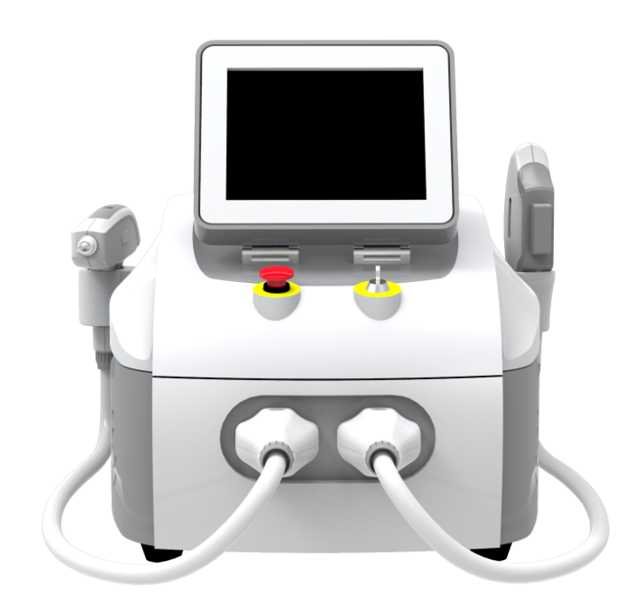

Disposal of your old appliance

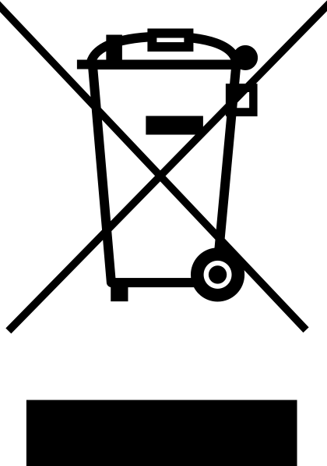
- When this crossed-out wheelie bin symbol is attached to a product it means the product is covered by the European Directive 2002/96/EC.
- All electrical and electronic products should be disposed of separately from the municipal waste stream via designated collection facilities appointed by the government or the local authorities.
- The correct disposal of your old appliance will help prevent potential negative consequences for the environment and human health
- For more detailed information about the disposal of your old appliance, please contact your city office, waste disposal service or the shop where you purchased the product.
Chapter 1 Introduction
Laser handle
SHR or IPL handpiece
Quick stop switch
Key Switch
SHR and IPL connector
Laser connector
10.4’’ movable color touch screen

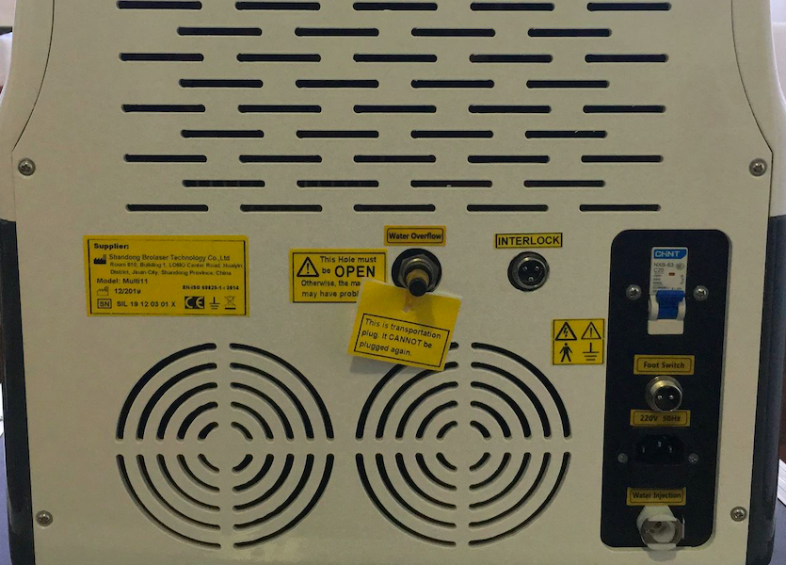
Water overflow hole
Power socket
Water injection and Water discharge hole
Air switch
Foot switch
Interlock

Chapter 2. Installation
1. Raise the screen slowly.
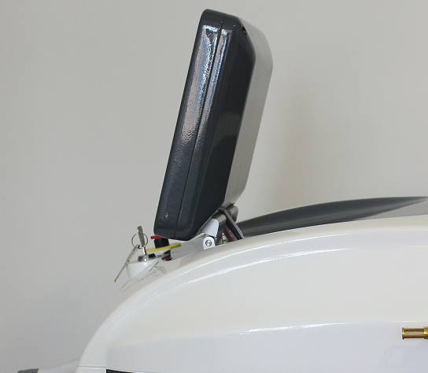
2. Connect the two handles
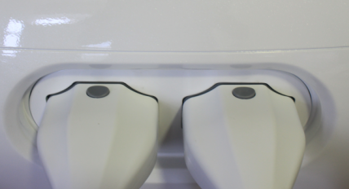

2.1 How to connect.
2.1.1 Press down the 2 buttons firstly.
There are two buttons on both above and below of each handpiece. The two buttons may be in the upspring or press-down state. Before connect it onto the machine, it must be in the press-down state. So press down the 2 buttons firstly.

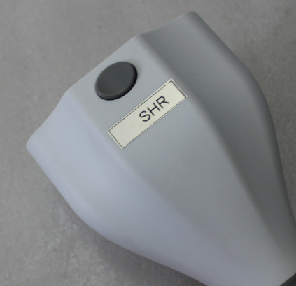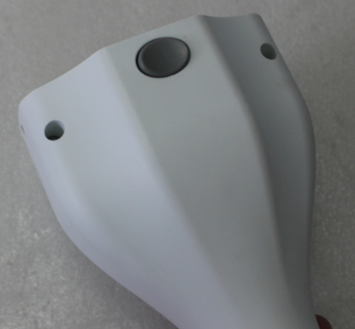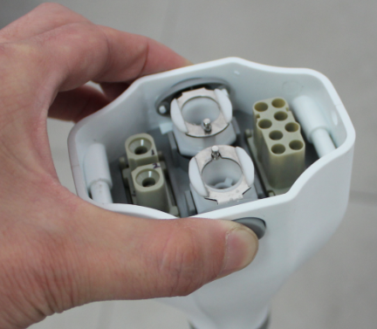

2.1.2 Connect it in the right direction.
There are two parts of the connectors: machine part and handpiece part. Please look at the following pictures. A1 connects to B1, and A2 connects to B2. It cannot plug if connecting A1 to B2.

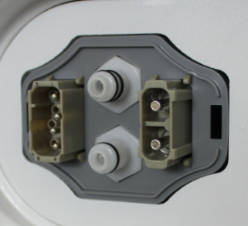
Machine part
Handpiece part
A1
A2
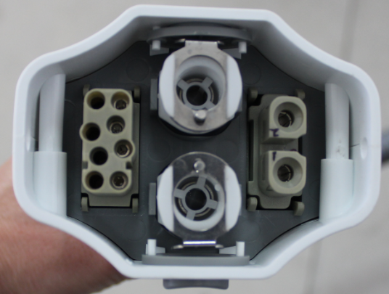
B1
B2

2.1.3 Use some power of your hands to plug it. When you plug one well, you can hear the click – the button springs and it locks. Then you can try to pull the handpiece connector slightly to check whether or not it locks well. Then hang up the two handpieces onto handpiece holders.

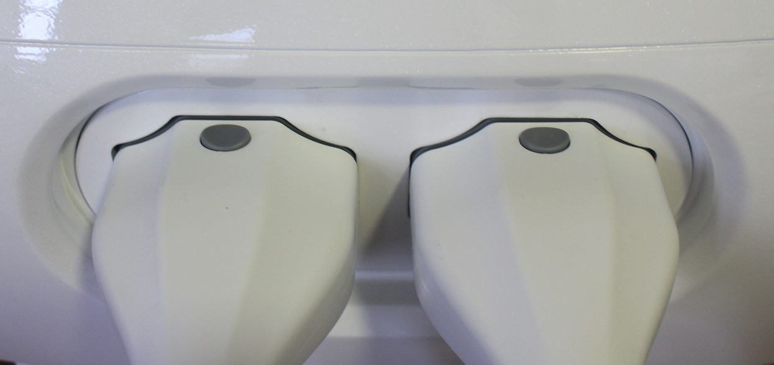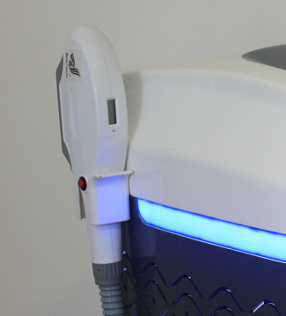

3. Connect foot switch
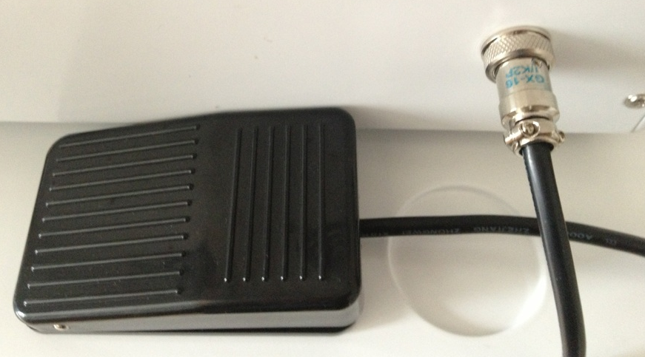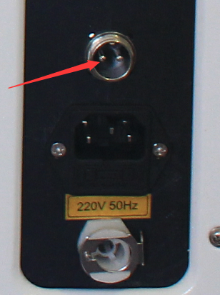

4. Water-in.. Pure water or distilled water necessary.
4.1 First, remove the black connector. After the water-in, you do not need put it back again.

4.2 Press the button on the water-in-hole.
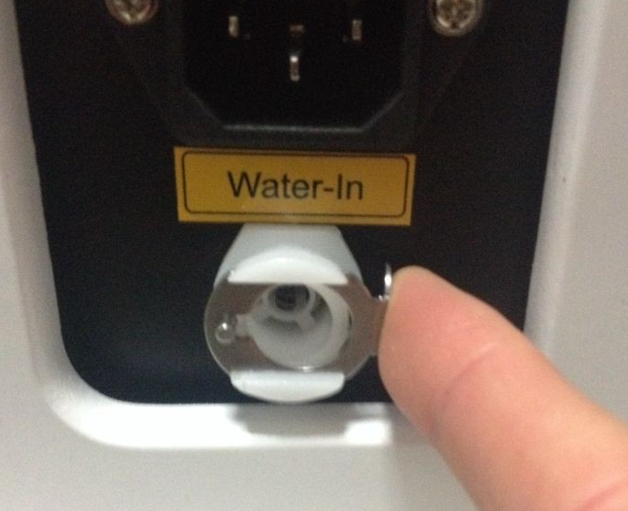
Insert the water pipe with plug and add water via funnel.
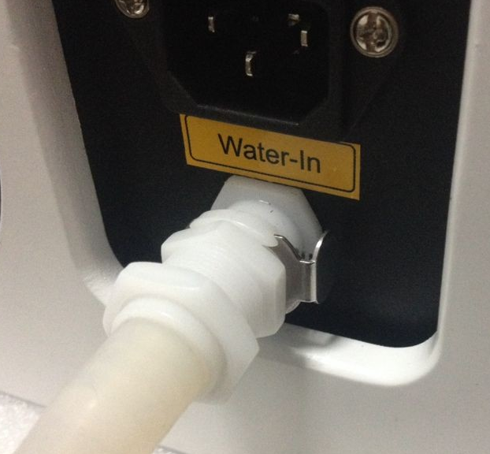
Add water until water runs from Water Overflow hole.
Press the button on the Water-In mouth, the water pipe pops out automatically.
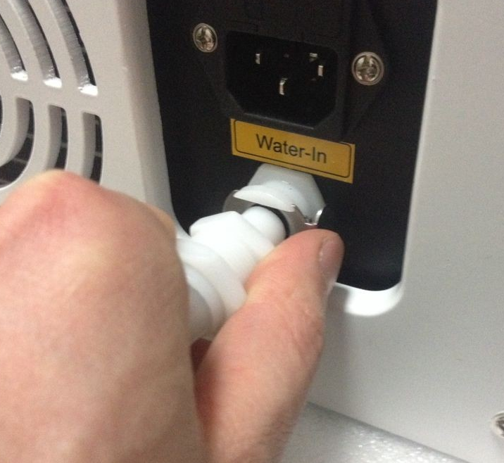
Connect Interlock
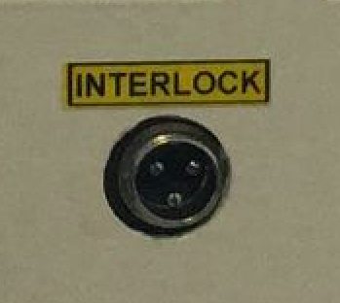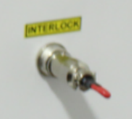

Chapter 3 Operating for SHR system
1. Connect the power. Turn on the machine by the key switch. If the machine has nothing reacts, turn the Quick Stop.
You see System Loading…. Just wait for seconds
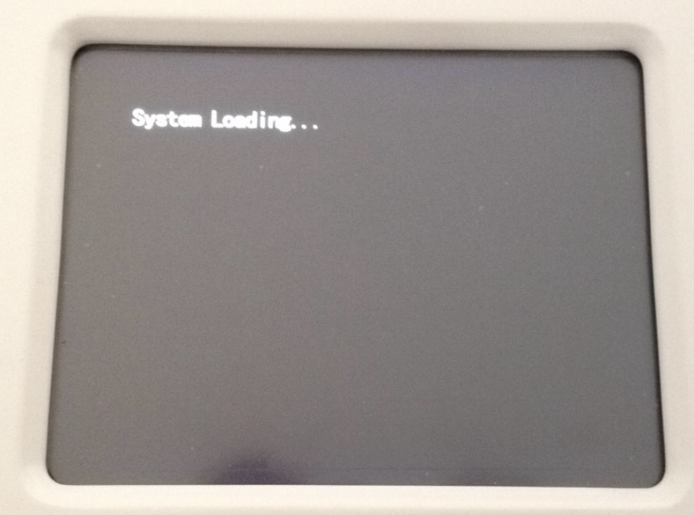
2. Then next screen. This screen saved for add customers logo. If no special requirements, there will be no logo here or the producer’s logo.
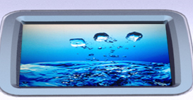
3. Click the above screen, we are in:
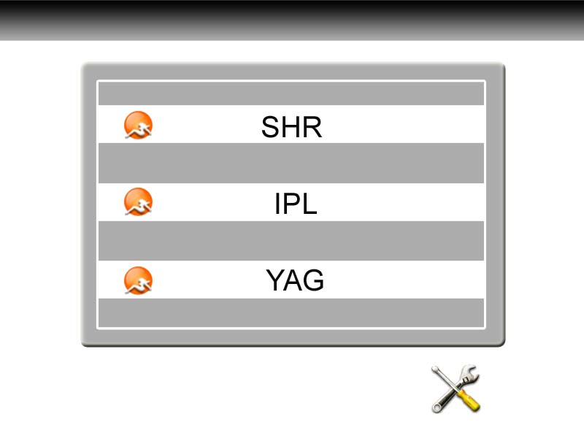
Click SHR, we go to:
②Treatment interface
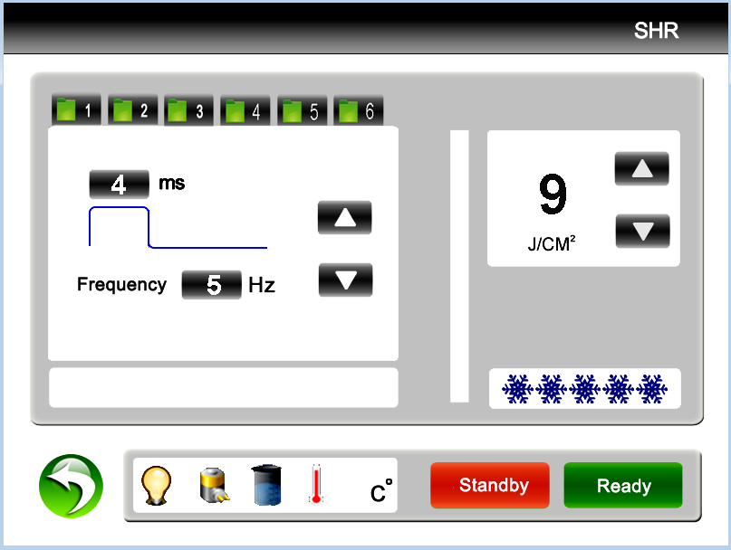
Pulse width
Frequency
Counter
Status notification

Return Key

6 settings memories
Ready /standby
SHR energy adjustment
Contact cooling

Click Handle cool levels into full levels (from gray to ) and the sapphire becomes cold in 1 or 2 seconds.
Pulse width: how long a shot work on skin. 1~7ms adjustable
Frequency: how many shots in one second. 1~10Hz adjustable
Energy:
- when the frequency is 1hz/2hz/3hz/4hz, the energy is 1-50J adjustable
- when frequency is 5hz, energy is 1-35J adjustable
- when frequency is 6hz, energy is 1-30J adjustable
- when frequency is 7hz, energy is 1-25J adjustable
- when frequency is 8hz, energy is 1-20J adjustable
- when frequency is 9hz, energy is 1-15J adjustable
- when frequency is 10hz, energy is 1-10J adjustable
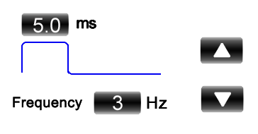

When to adjust pulse width or Frequency, you need click the figure into red color:
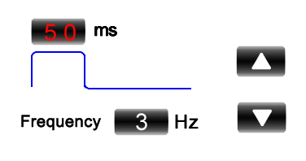

Then click  to increase it or to decrease it. Then click the red figure into white color again, or other settings are not able to change.
When you test the machine, you can use pulse width 3ms, frequency 3hz and energy 5J. Then raise the settings slowly according to actual situation.
When settings are ready, press "Ready” button to trigger the treatment head and to charge the capacitances automatically. Press the red button and it shots.
When treatment finishes, press "Standby” button to turn off the head.
Status prompt window 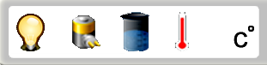

When the machine is Standby, it shows. When click Ready, it shows .
It may change between  and  during fast shots. It is normal.
When the water cycling is bad, the machine alarms and it shows .
When water temperature is too high, the machine alarms and it shows .

Operation

1. Shave the hair
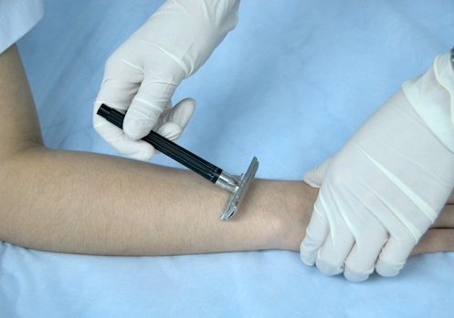

Daub ultrasonic Gel on the skin in 1-2mm thick.
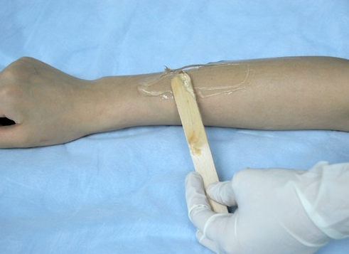

Please pay attention the way of handle during the treatment.

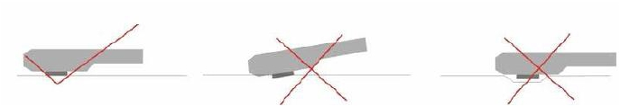
- Smear gel on the skin about 2 to 3 mm thickness before treating.
- Start the machine, processing step by step and adjust the suitable parametre.
- While exerting light pressure, approximate the treatment head perpendicularly over the treatment area. Ensure both metal slices of the head touch the skin naturally at the same time during treatment, If only one side metal slice touch the skin, it can be easily burnt skin. See above picture (1)Then can press the red bottoms to treatment. Before the treatment head leave the skin, please loose the red buttom first then treatment head can be off the skin.
- When the skin is in red after operation, coat the cool gel till the red is die out. Do not wash with water.

- Principles adjusting of parameters.
The white skin and lighter Skin | 1.Increase the power engery
The white skin and lighter Skin | 2.Decrease the pluse delay=(pluse interval) more cooling
The daker skin | 1. Decrease the power energy
The daker skin | 2. Increase the pulse delay ( allow more cooling)
The lighter the hair /pigments | 1.Increase the power engery
The lighter the hair /pigments | 2. Decrease the pluse delay= ( pluse interval)
The darker the hair/ pigment lesion | 1. Decrease the power engery
The darker the hair/ pigment lesion | 2.Increase the pluse delay= (pluse interval) more cooling
Fine Blood Vessels ( vascular lesion) | 1.Increase the power engery
Fine Blood Vessels ( vascular lesion) | 2. Decrease the pluse delay= ( pluse interval)
Thick Blood vessels | 1. Decrease the power engery
Thick Blood vessels | 2. Increase the pluse delay= ( pluse interval)cool more
The smaller the target size / lesion ( vascular) | 1.Decrease pulse delay
The larger the target size/ lesion ( vascular) | 1. Increase pulse delay ( allow more cooling )
Bony prominences (forehead, molar area, shin, bikini) | 1. Decrease the power energy

Chapter 4 Operation for ND YAG laser system

From the following screen. Click YAG
We enter laser treatment screen

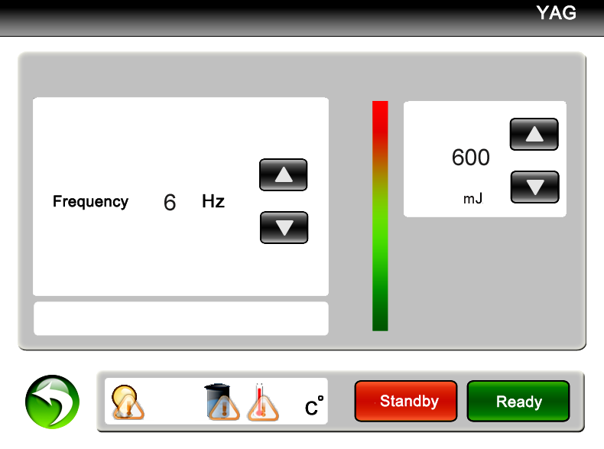
- Operation :
The interface display: status indication; treatment mode and the current treatment mode; the general counter and the current counter; treatment frequency; treatment energy; operating key-press indication.

Press the key or the to raise or low the Frequency or Energy.
PLEASE NOTE: Different treatment modes require different frequencies and energy levels accordingly.

Press the key and the machine goes into the preparation working state. You can hear crisped sound as you touch this key.

Test and adjust suitable parameters on a non-treatment area. Operators can test between dark magazines or dorsum of hand, at the same time the operator press
the kick pedal with foot and hold the hand piece with your right hand. Aim the treatment tip towards to the testing area to examine the light energy which is emitted, you can see the shining light and hear the sound “ba ba”. The size of testing area is about 1cm² and the paper will turn white, and you can feel a slight tingling sensation .

After selecting the correct Mode, Energy and Frequency, aim the laser towards treatment area, press the foot switch and apply treatment accordingly.

2 To Pause Operation
- First you loosen the kick pedal and press if you need to pause the machine. The other way is press the red “Emergency Switch” directly. The machine will be in safe condition. The laser light will not output if you touch the kick pedal.
- If you need to continue to operate this machine, please press , then you tread the kick pedal and the machine will operate again. Lift the emergency switch if it was pressed.

3 To Shut Down the Machine
- Remove foot from the kick pedal and remove the hand piece away from the treatment area to stop treating.
- Press the key .
- Place hand piece securely into holder.
- Turn key counter clockwise and remove to prevent unauthorised use.
- Switch off power supply.

4 Emergency Shut Down
- Press red emergency button
- Turn key anticlockwise and remove

5 Treatment Shot Counter
During the treatment, the counter can record the shots/flashes during treatment. The counter includes current counter and general counter. The current counter (used to record shots/flashes of unit treatment) can record from 000000—999999. The general counter (used to record total shots/flashes of the machine) can record the number from 00000000—99999999.

The last used parameters in different treatment modes are saved even if you close the power supply. You can change it only when you change it to new parameter.

6 Temperature Display and Protection
There is error protection function for monitoring the water temperature and circulation.
It will display “ERROR” in the relevant function area, an audible alarm will be emitted and the machine will cease to work. The controlling will exit when you touch any key, and turn to the welcome interface.

- Application:
The sapphire Q-switch laser tattoo & eyebrow removal equipment can effectively cure pathological changes of endogenous and exogenous pigment formed by mixed pigment--pigment deposit cause by operative errors on dark embroider eyebrow, embroider lip, soak lip, embroider eye line, lip line, tattoo (including traumatic tattoo), allergy source pigment, such as black, blue, green, purple, brown and red color in freckles, cafe-au-lait spots, age pigment, black naevus, etc.

- Reference table of all kinds of treatment period of case history:

Case | Treatment  times | Treatment intervals  (intervals of two  treatments) | Remark  (requirements in treatments)
Embroider eyebrow | 1~3 | 30~45 days | protect eyeball when treating eyebrow
Embroider eye line | 1~3 | 45~60 days | protect eyeball when treating eyebrow
Tattoo | 1~4 | 30~45 days | Good effect if blood spots occur
Age pigment  Fleck | 1~4 | 30~45 days | Good effect if blood spots occur
Nevus  Birthmark | 3~7 | 30~45 days | Good effect if blood spots occur

Adjusting The Focal Point (Spot Size)

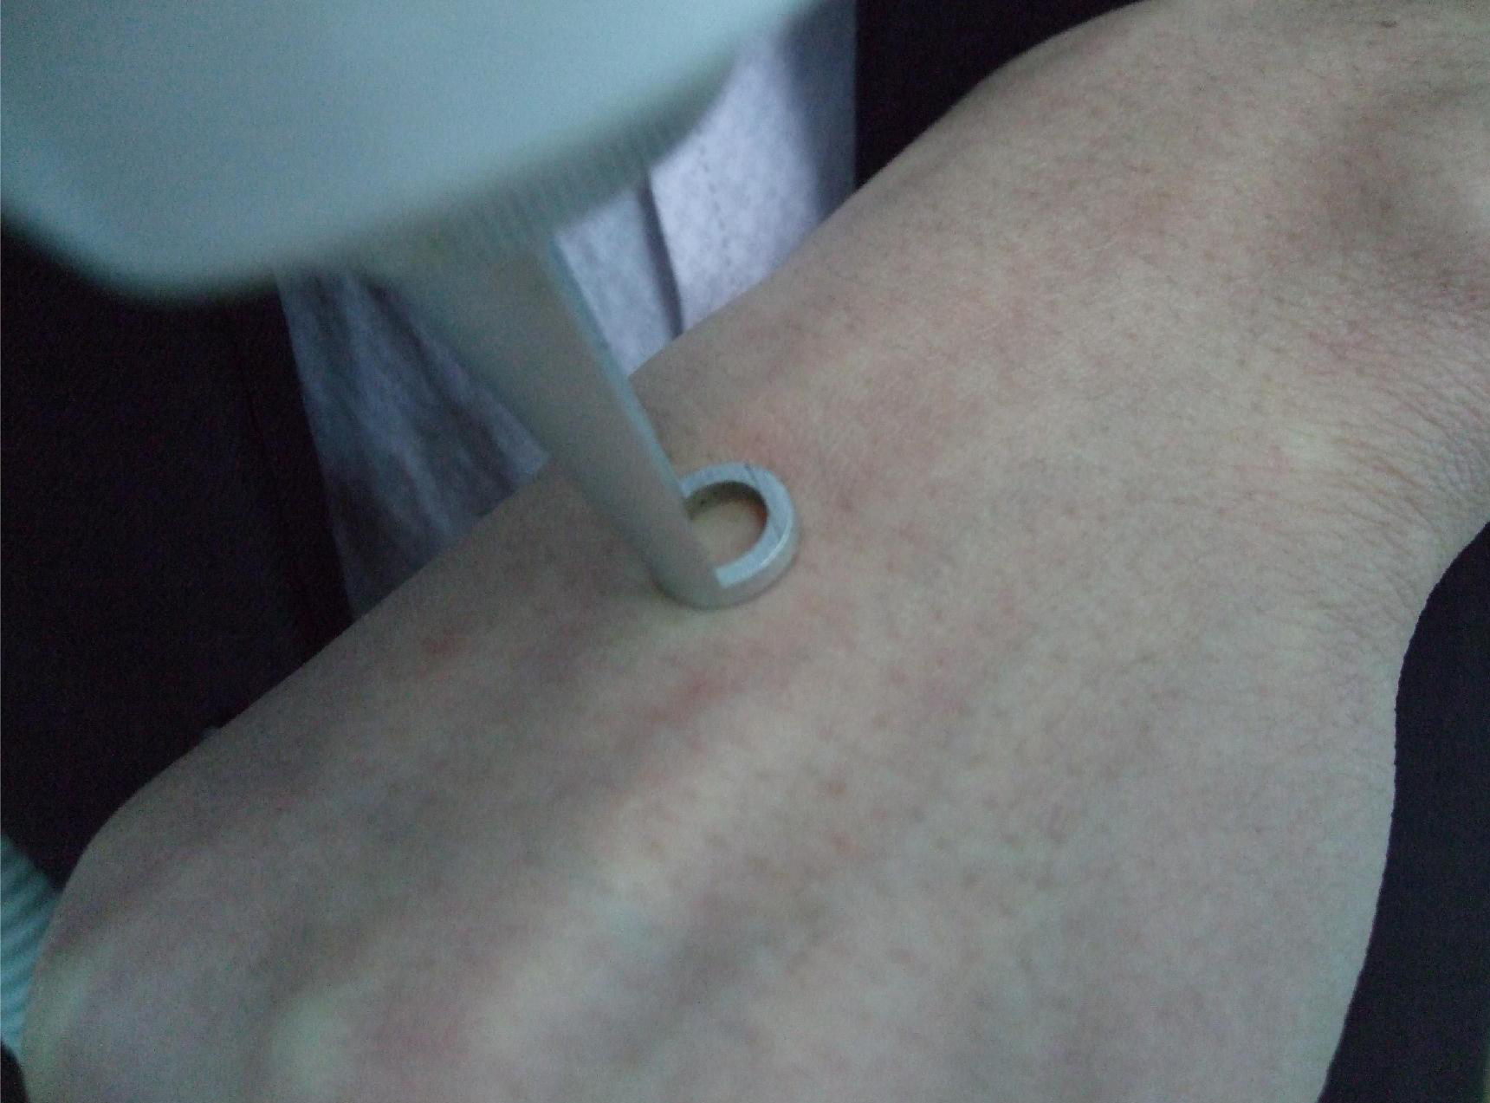  1. Put the head on the skin first | 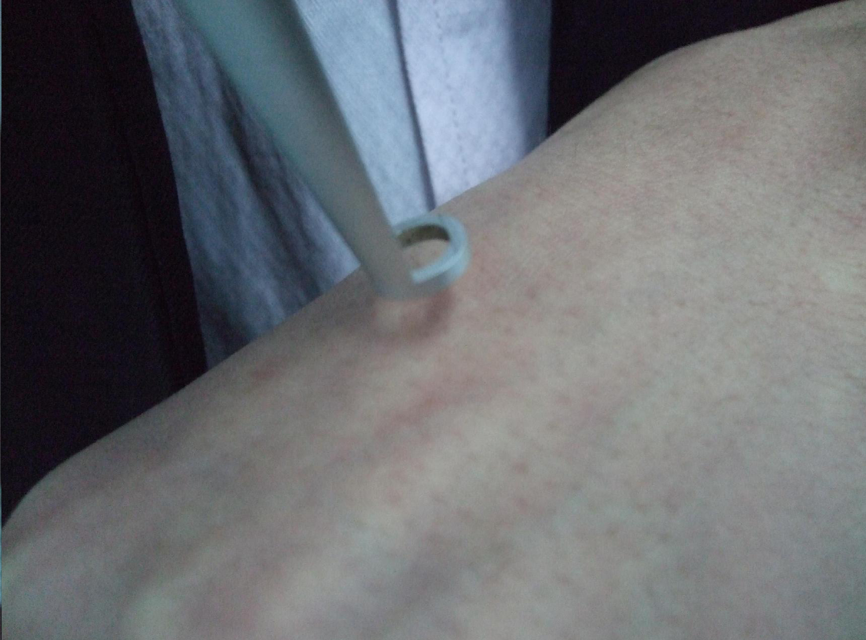  2. Then, prolong the distance between skin and head.
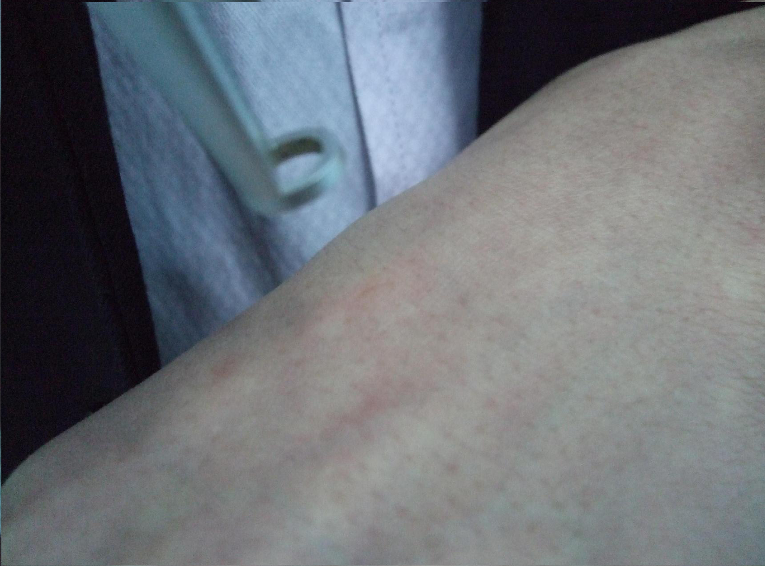  3. The power is most strongest when the laser beam get the focus. | 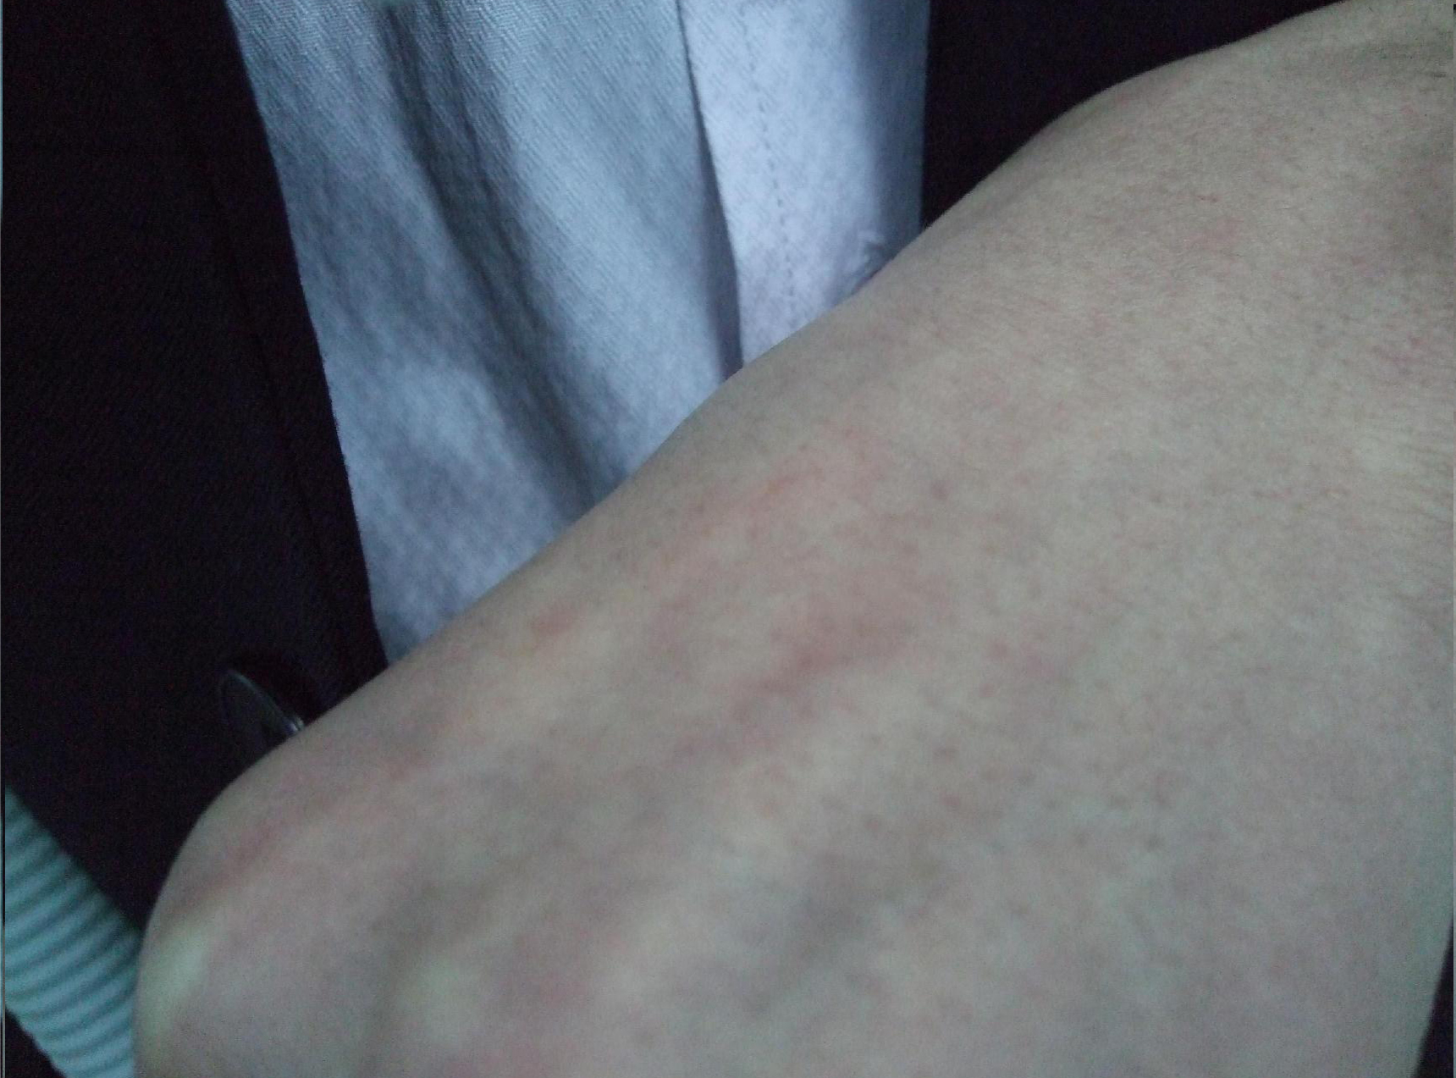  4. Power will be weaker again after the distance between skin and head is longer than the focal point.
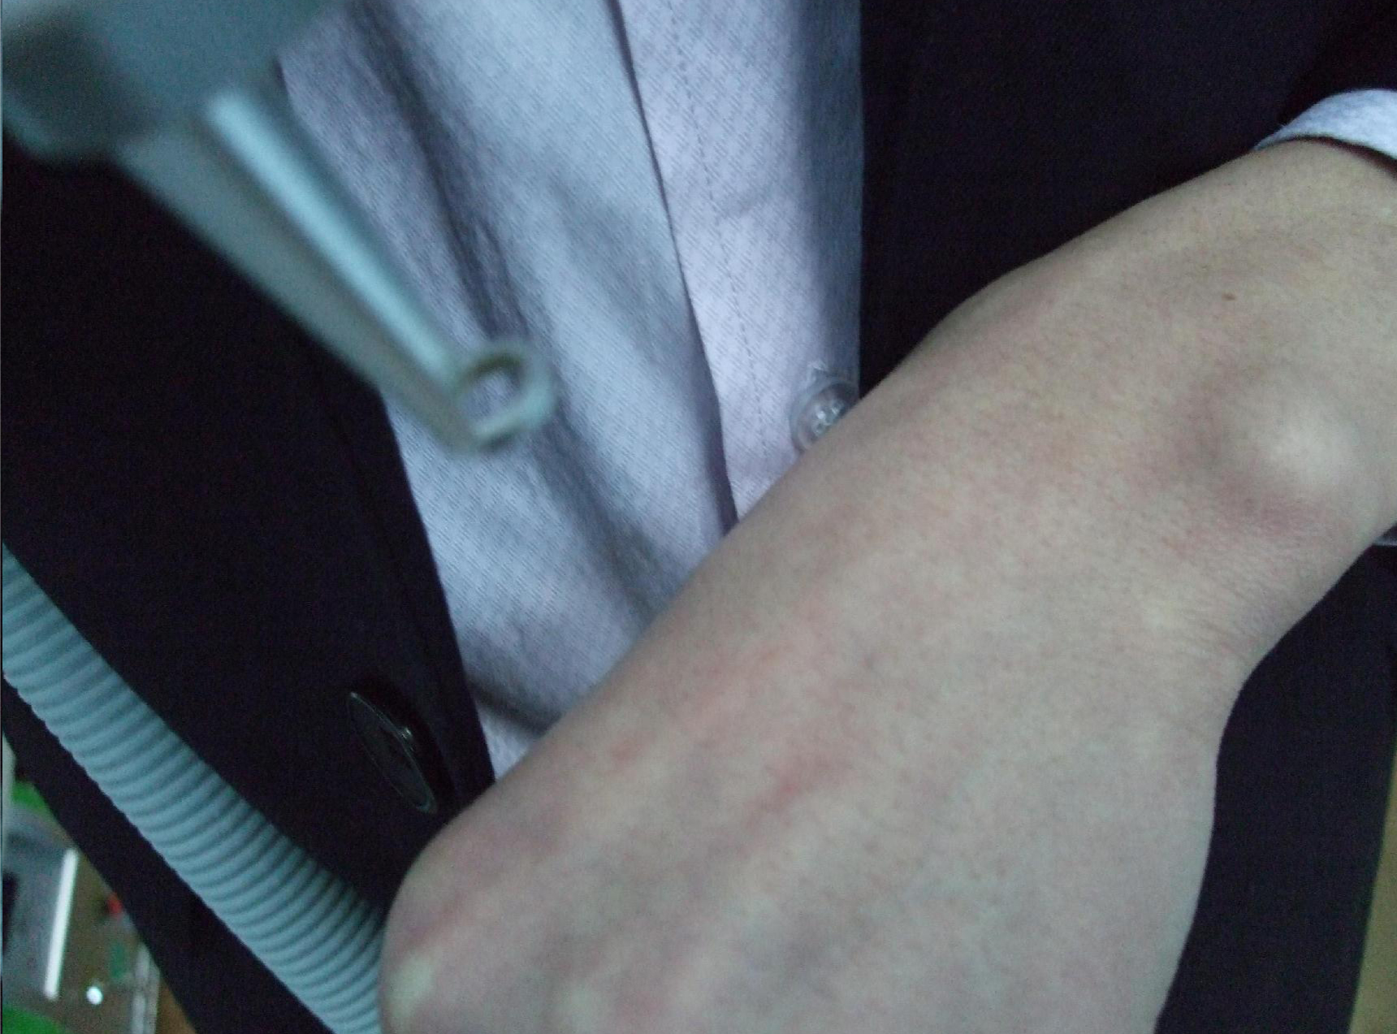  5. Looking for a good distance to control the power during the treatment. | Notice:  Larger Focal Point (spot size) = Lower Power Density  Smaller Focal Point (spot size) = Higher Power Density.

IPL operation
 Notice
SHR handpiece and IPL handpiece share one socket on the machine. The machine must be turn off when to change another handpiece. Then turn on the machine again after changing handpiece.

Press IPL 
Then enter:
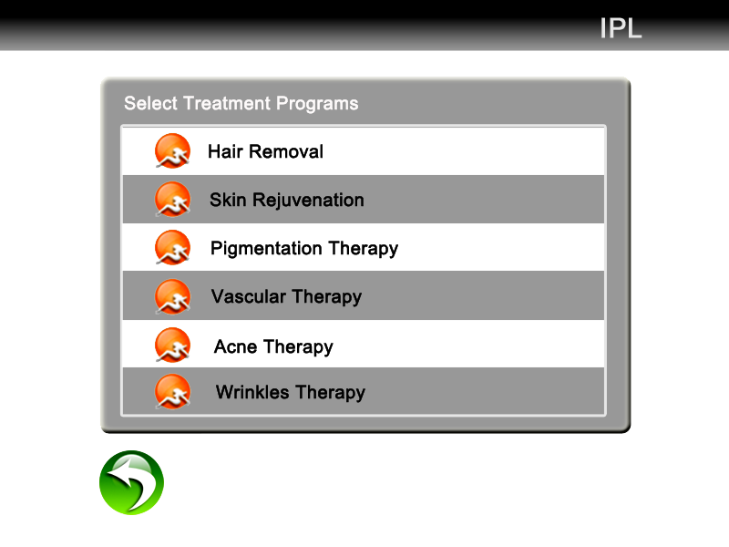
So you can select any function you want. Let’s take Hair Removal for an example. Click Hair removal on the above screen. Here we go:

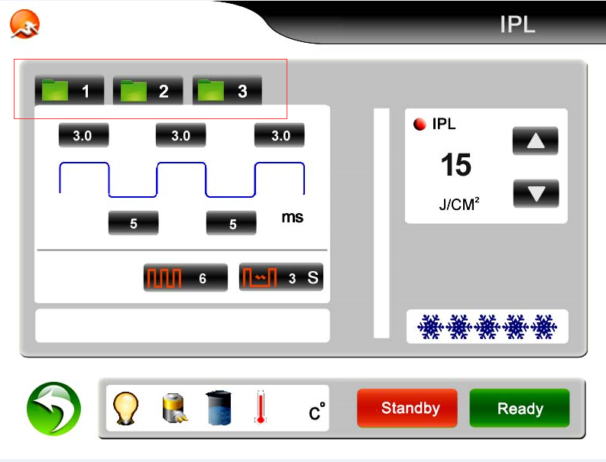
Ready /standby/
Return key
IPLenergy adjustment
Therapy parameter set
Head cooling temperature selection coolingtemperature selection
Status notification
Treatment records

Introduction of the screen:
Settings Storage : to store a group of personalized parameters. 3 files in each application.
Pulse number : it is seepage force. More number, stronger seepage force.
Return: to the screen to select functions
Flash interval ：To adjust the discharge interval, the adjusting extension is 1~5S, you can touch different figure. It the interval time bewteen the two adjacent flashes if keep pressing the switch on the handle.
IPL energy adjustment: to adjust the output energy of the light head. The adjusting extension is from 1 to 50 J/cm2. It can be changed during your treatment through clicking “△or▽”, “△”means up while “▽”means down.
Contact cooling level: to adjust the amount of snowflake from the left to right
The first pulse duration: to adjust the first pulse width, the pulse width is the single pulse which be used, otherwise the first pulse width is the pulse width while many pulses be used. The adjusting extension is from 1 to 10ms by 0.1ms step in.
The first pulse interval: to adjust the stay time between the first pulse and the second pulse, the adjusting extension is from 1 to 100ms by 1ms steps in.
The second pulse duration: to adjust the second pulse width, it will not display when single pulse be used. The adjusting extension is from 1 to 10 ms by 0.1ms step in.
The second pulse interval: to adjust the stay time between the second pulse and the third pulse, it will not display when single pulse be used, the adjusting extension is from 1 to 100ms by 1ms steps in.
The third pulse duration: to adjust the pulse width between the third and the fourth, it will not display when the single pulse be used, the adjusting extension is from 1 to 5ms by 0.1ms step in.
The treatment parameter can be changed, and you can adjust the parameter on the pulse wave pattern. The folder should be clicked again for saving the parameter after you input the needed number. The number will not be changed if the number is too big.

Sketch map of the pulse inputting
The second pulse width
The third pulse width
The first pulse width
The first pulse

The first pulse interval
The second pulse interval

When you finish changing one value on the screen, you must click the value again to confirm it. Then you can go on changing other values.

IPL handpiece
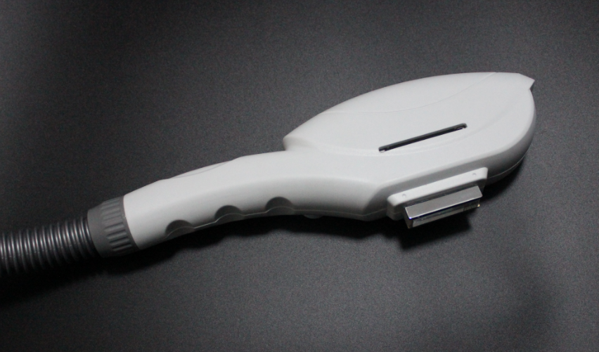

How to use filter for the IPL handpiece:
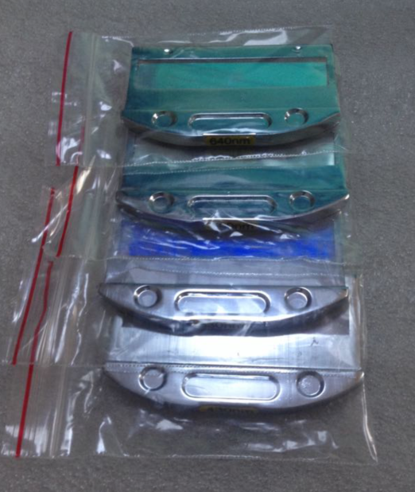

Standard spectra | Application areas
430-1200nm | Acne therapy
530-1200 | Pigment、photo rejuvenation
590-1200nm | Vascular/spider veins
640-1200nm | Hair removal

Choose a right filter and install it onto the handpiece

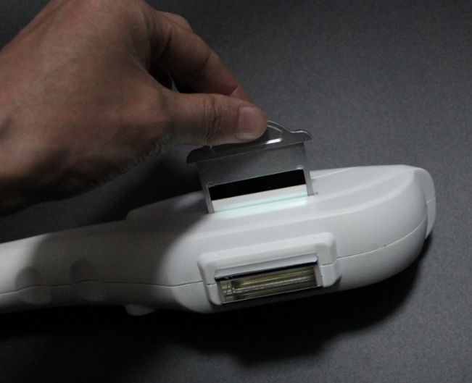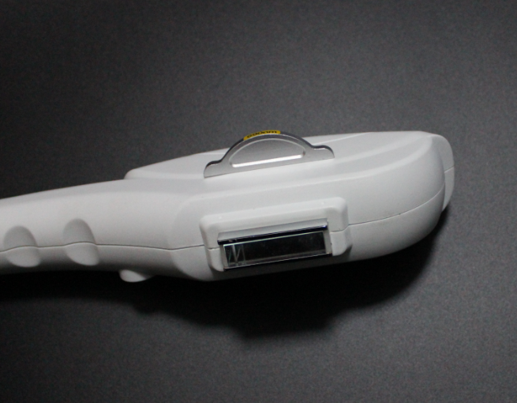
When all the settings are ready, click Ready. You can hear PA. And at the same time the light in the handpiece is on.

Shave the hair

Daub ultrasonic Gel on the skin in 1-2mm thick.

Please pay attention the way of handle during the treatment.

- Smear gel on the skin about 2 to 3 mm thickness before treating.
- Start the machine, processing step by step and adjust the suitable parametre.
- While exerting light pressure, approximate the treatment head perpendicularly over the treatment area. Ensure both metal slices of the head touch the skin naturally at the same time during treatment, If only one side metal slice touch the skin, it can be easily burnt skin. See above picture (1)Then can press the red bottoms to treatment. Before the treatment head leave the skin, please loose the red buttom first then treatment head can be off the skin.
- When the skin is in red after operation, coat the cool gel till the red is die out. Do not wash with water.

- Principles adjusting of parameters.
The white skin and lighter Skin | 1.Increase the power engery
The white skin and lighter Skin | 2.Decrease the pluse delay=(pluse interval) more cooling
The daker skin | 1. Decrease the power energy
The daker skin | 2. Increase the pulse delay ( allow more cooling)
The lighter the hair /pigments | 1.Increase the power engery
The lighter the hair /pigments | 2. Decrease the pluse delay= ( pluse interval)
The darker the hair/ pigment lesion | 1. Decrease the power engery
The darker the hair/ pigment lesion | 2.Increase the pluse delay= (pluse interval) more cooling
Fine Blood Vessels ( vascular lesion) | 1.Increase the power engery
Fine Blood Vessels ( vascular lesion) | 2. Decrease the pluse delay= ( pluse interval)
Thick Blood vessels | 1. Decrease the power engery
Thick Blood vessels | 2. Increase the pluse delay= ( pluse interval)cool more
The smaller the target size / lesion ( vascular) | 1.Decrease pulse delay
The larger the target size/ lesion ( vascular) | 1. Increase pulse delay ( allow more cooling )
Bony prominences (forehead, molar area, shin, bikini) | 1. Decrease the power energy

Chapter 5 Safety Attentions
- Laser safety:
  - According to laser radicalization safety, laser eyebrow & tattoo removal equipment belong to the fourth laser product;
  - Laser is invisible infrared light, wherein, the 532nm laser is a light that is green, dazzling visible light. Accordingly, any operator shall wear a pair of goggles with wavelength range 200~1080nm;
  - The laser window is located at the bottom of the treatment head. Anyone must avoid radiation;
  - Anyone should never look directly at the bottom of the treatment head or any reflecting laser light;
  - Keep combustible and explosive stupefacient, liquid, gas (for example: ethanol aether laughing gas oxygen and so on away far from laser radiation area and defend measures should be taken;
  - Don’t irradiate laser to metal devices, or laser is reflected and is dangerous to anyone around;
  - No reflecting things worn, such as watch, necklace, bracelet, etc;
  - Must offer safety sound safeguard to sufferer’s eyes, when removal eye line, the worker must keep out sufferer’s eyeballs by gauze, the worker should have ophthalmic clinic experience and strict according to company training way.
  - Different pigment assimilate different laser, the choice of dosage must from small to big.
  - Our company advice you prepare special laser room and prepare air-condition or xerantic machine and paste treatment notice matter.
  - Notice: big facula relative lesser power density, small facula relative biggish power density.
Power density = power big or small / facula acreage
- Eye safety:
  - Any operator in operation area shall wear goggles (200—1080nm) and any sufferer’s eyes shall be protected strictly and effectively;
  - Never look directly at laser or reflected laser even wearing goggles;
  - Using gauze or eyelid plate to cover eyes, wearing goggles are all effective to protect sufferer’s eyes. Wherein, humid gauze to cover eyes is more effective, but treatment part should be dry;
  - The equipment should be off power when debugging laser or clean laser lens.
- Electric safety :
  - According to electric shock egis sort, the laser eyebrow and tattoo removal series belong to Ⅰ- B model general equipment.
  - Connect measure up international monomial three line electrical outlet, the spec 10A upwards.
  - Steady voltage.
  - After stop the machine, it inside still leave behind remnant voltage, so can’t optionally take apart machine.
- Carry safety :
  - The machine is portable equipment, move easy.
  - Must not hit the light head of treatment, because it has exact optics system.
  - Keep water pipe expedite and treatment handle should be packaged by sprung materials.
  - Before carrying, must take away apertured cover of water tank, instead of imperforate cover of water tank.

Chapter 6 Operation of Laser Instrument

  - Notice
⑴first you should ask the customer if he\her is scar physique, if had changed skin, if he\her is allergic skin, if he\her is shaded eyebrow or removed eyebrow, tattoo by other ways. You should examine that if the treatment area already has scar, and you should tell the sufferer that maybe there is pigmentation some times later after you remove the pigment, and these pigment is caused by sunshine and he\her can get treatment one and a half months later.
⑵、the operator should tell the sufferer that may happened situation and treatment principle during the treatment using the 1064nm to treat the black and blue pigment in case the unnecessary bothers.
You can shave the eyebrow before removing the eyebrow with machine in order to examine the effect. We advise you that you should treat the big area tattoo and nevus little by little and time by time in case uncomfortable of the sufferer. You can also help the sufferer to build the confidence according to the contrast between before and after the operation.
⑶、There maybe the sound of the pigment breaking when you treat the deep tissue of the tattoo because of the strong absorption to laser energy with 1064nm. The tint color of the pigment can comes out the cuticle after absorbing the energy. Some people may have some drops of drain blood because of thin cuticle. In the first time treatment, the color of the tissue may become thin, but later the color may recover about ten minutes later. This kind of effect is normal. The function of digesting and transportation of the macrophage can continue long time, and the color can become thin during this period. We advise you take the second treatment one and a half months later of the first time. The eye is more sensitive, so it tears to influence the effect; generally we take two times to get into the effect.
⑷、The hair may exfoliated after operating as you remove black and blue pigment with 1064nm, but the new hair can tend to normal. There may ooze blood and tint edema in the treatment area. It will be normal if there is the feeling of itch and the tissue is a little hard. All these feeling will disappear in two weeks or about a month, and the time is different according to different people.
⑸、 Hemoglobin of the tissue absorbs certain wavelength of the 532nm when you remove brown, red pigment with 532nm. The surface of the skin irradiated by laser may turn white, so as to making the pigment drops and pigmentation.
(6)、The capillary may break and form congestion as absorbing the wavelength of 532nm, if serious can cause scab. But it is well in about 20-60 days according to different people.
⑺、The sufferer will be forbidden drawing eyebrow, bathing and touching in the blood oozing area, and avoid shinning in case causing pigmentation. If serious, the sufferer can take some medicine and erytheromycin ointment which external used followed by doctor. You also will not allowed to take pepper food and alcohol.
  - operation skill and technique
- demands before operation
- Cosmetologist should build file for customer in order to well know about the real disease and choose the needed energy; at the same time the cosmetologist should explain the advantages of laser machine in order to make the customer to relax and cooperate.
- Clean the treatment area, disinfect utensil, shave the eyebrow, and wipe affected part with physiological saline. You must pay attention that the affected part must be dry, and the treatment will be affected if there is water in the affected part.
- The worker should wear white clothes and relevant wavelength glasses. Keep the operation room clean and illumination is bright enough. You should keep the temperature is between 22 and 28℃, and avoid the laser irradiating non treatment area.
⑵ Demands during the operation
- the needed frequency during the operation

Treatment Mode | Frequency | Treatment Distance | Energy
Eyebrow removal | 2--3Hz | 1—2cm | 300—400mj
Eye line removal | 2--3Hz | 1—2cm | 300—400mj
Lip line removal | 2—4Hz | 2—3cm | 300—400mj
Tattoo removal | 2--4Hz | 3—5cm | 500—600mj
Spots and naevi removal | 2--4Hz | 3—5cm | 500—600mj
Birthmark removal | 2--4Hz | 3—5cm | 550—700mj
Notice:
① 1064nm gets rid of blue, black and cyanine pigment.
② 532nm gets rid of red, coffee and brown pigment.
③ the light head should form right angle with treatment area in order to reduce the energy losing. The light spots should fold and translation to a line when you remove eyebrow, eye line and lip line. You should remove the spot and naevus time by time in the little area. The treatment area should ooze blood when you treat the little area.
⑶The reaction during the operation and recovery after the operation
The pigment of the lesion tissue is broken into gains small enough to be absorbed and digested by macrophage. Part of the particles which in the superficial is discharged from the body and the other part which in deep tissue is regularly permutated in superficial, so the tattoo can return in short time. It will be normal if part of the skin becomes red swelling, blister and even blood oozing because the black pigment absorbs the energy strongly when you treat the deep tattoo. The degree is different according to different people, and you can feel a little itch and hard of the tissue. Generally speaking, the uncomfortable will disappear in 3-7days, but it may take 1-3 months for some special constitution.
You will not be allowed to draw eyebrow, take shower and get sunshine after getting treatment. You also should change the bad dietary habit followed the doctor. You can’t take alcohol in 3-7days. We suggest that you should take antibiotic if blood too more and serious swelling after treatment. You can daub erythromycin ointment to help to heal in the recovery period.
⑷ the determinants for which pigment is different to dispel
  - The quality of the texture of the pigment, the pigment divided into plants pigment, mixture pigment, and chemical pigment. The plants pigment is dispelled easiest while the chemical pigment is most difficult to dispel. Generally, there are iron and lead in the mixture and chemical pigment, so it is different to remove.
  - The depth of the pigment. Generally speaking, the deeper of the pigment, the more difficult to remove. And it also takes many times to dispel. It will easy to dispel if the depth of the pigment is thin. The effects will not well if the pigment is chemical even the depth of the pigment is thin.
  - The different physique of people. The factors include age, skin, and body immunity and so on.

