Manual of Users

Model Number: VOYAGER PRO 2

Chapter 1 Introduction

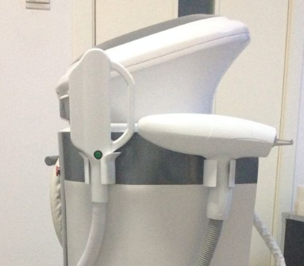
YAG laser handpiece
E-light handpiece
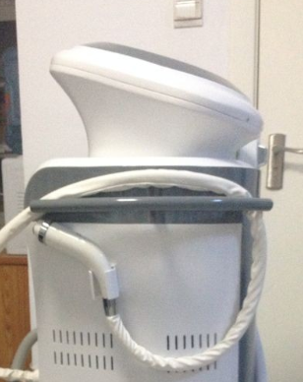
RF handpiece

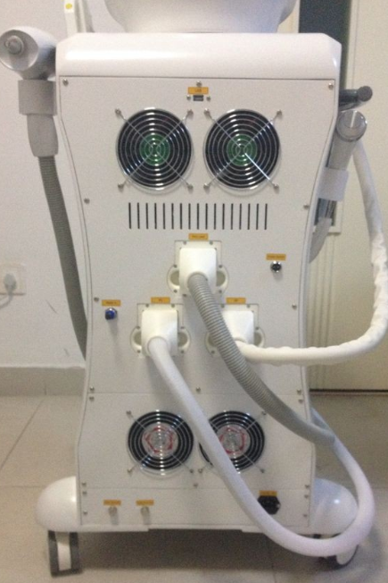
USB port
Foot switch connector
YAG laser connector
E-light connector
RF connector
Discharge water
Overflow water
Electrical power

Chapter 2 Installation

- Install handpiece holders
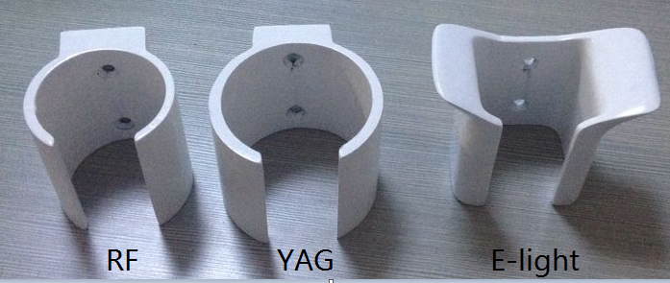
- YAG holder and RF holder looks similar but YAG holder is bigger than RF holder. Please install the 3 holders as the following way.
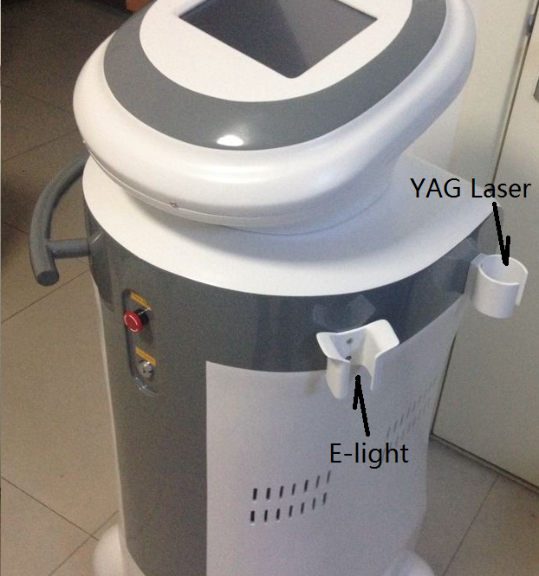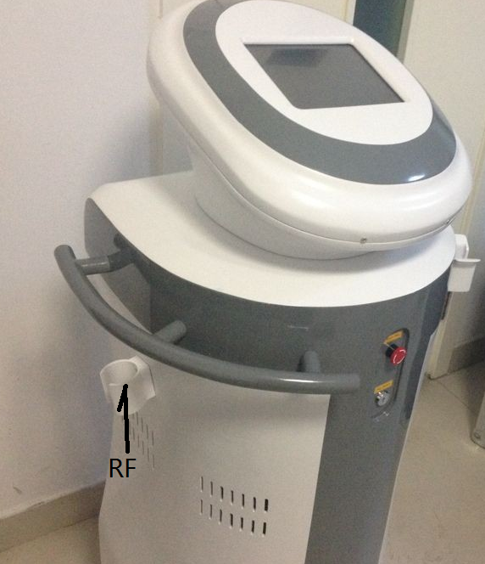
- Connect the two handles
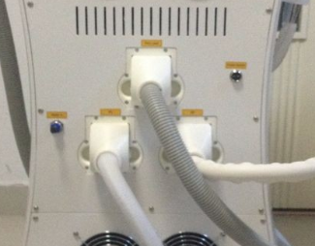
When to connect the handle onto the machine, please:
- don’t draw the handle hose too hardly, or the handle may be pull off from the holder and drop on ground leading to broken
- please push-in the two lock buttons on both side of the handle plug
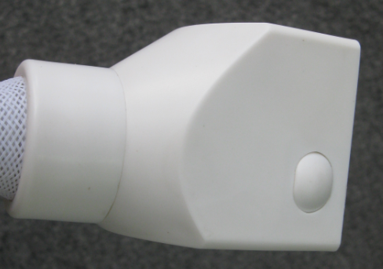

Push-in
Some strength is needed to connect the handle plug onto the handle socket. You should hear two sounds pa…pa or the two sounds happen at the same time. The lock buttons bounces. That’s means the connection is finished. Or you need to re-connect it.
- As the handpiece tubes are long, you can hang them in the following way to avoid dragging on the ground.
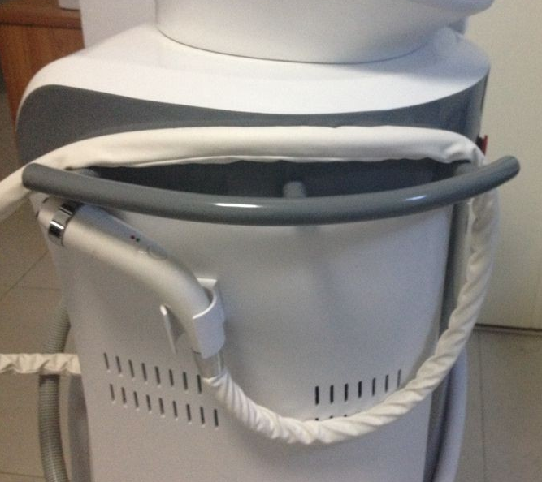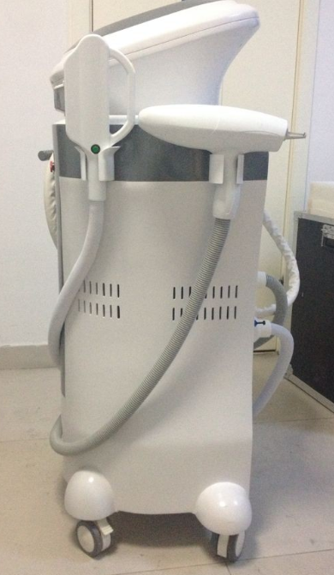
- Connect foot switch
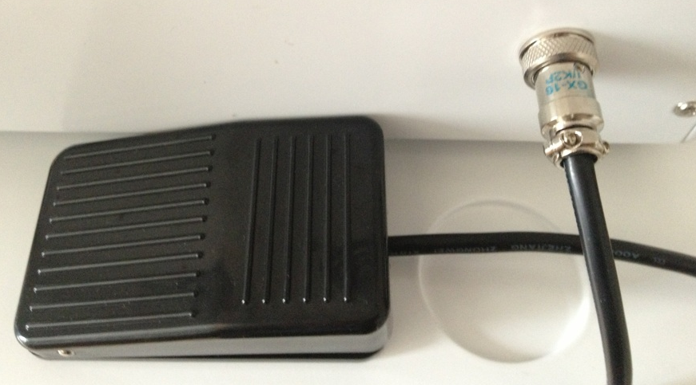
6. Water-In
You should see a label on the machine says “The machine must be filled in water before turning it on; otherwise it may lead to broken”. Pure water or distilled water is needed.
Before Water-In, please take down the two plugs in the Water-In and Water Overflow on the back of the machine.
The method to take down the two plugs is to 1) push in the blue outlet and 2) pull out the plug at the same time.
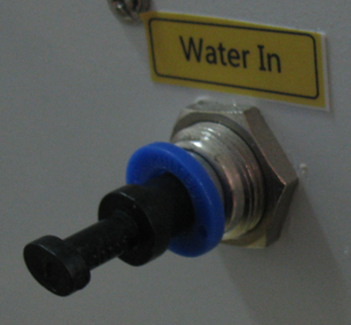
1. push in the blue outlet
2. pull out the plug
 After adding water, please don’t plug the Water In hole because the water cycling system produces air during the machine work. The air must be released, or the water cycling system may get damage.
Add water:
- Open the Water Overflow and get a basin ready under the Water Overflow.
- Connect water pipe and funnel.
- Add pure water or distilled water from Water-In until water runs out from Water Overflow.
- Close the Water Overflow.

Chapter 3 Technical Specifications
E-light | IPL Energy | 1-50J
E-light | Pulse No. | 1-6
E-light | Pulse Duration | 1-10ms
E-light | Pulse delay | 1-100ms
E-light | Pulse/Discharge interval | 1-4ms
E-light | Wavelength | 430/530/640/690nm standard (480nm, 560nm, 590nm, 750nm optional)
E-light | Spot size | 12x30mm,15X50mm optional
E-light | RF Duration | Max 2400ms
E-light | RF Energy | 1-20J/cm3
Q-switch ND: YAG laser | Laser type energy | Q-switch ND:YAG laser
Q-switch ND: YAG laser | Laser energy | Max. 1500mj
Q-switch ND: YAG laser | Pulse width | 3ns
Q-switch ND: YAG laser | Frequency | 1-6Hz
Q-switch ND: YAG laser | Laser wavelength | 532nm/1064nm
Q-switch ND: YAG laser | Spot size | 1-8mm adjustable
Q-switch ND: YAG laser | Aiming light | Optional
RF | RF energy | 1-20J/cm3
RF | RF mode | Continuous and Pulse
Basic specifications | Controller: | 8” color touch LCD screen
Basic specifications | Output powe | 3000W
Basic specifications | Program languages | English, Spanish, French, German, Italian, Polish, Japanese, Korean, Chinese
Basic specifications | Cooling System | semiconductor+ air + water + cooling gel
Basic specifications | Skin Cooling | ≤0-10⁰C
Basic specifications | Dimension of machine | 45*41*108cm
Basic specifications | Dimension of package | 68*55*133cm
Basic specifications | N.W. | 40kg
Basic specifications | G.W. | 65kg
Basic specifications | Voltage | 100V~240V
Chapter 4 Operating flow
1. Connect the power. Turn on the machine by the key switch. If the machine has nothing reacts, turn the Quick Stop.
You see System Loading…. Just wait for seconds
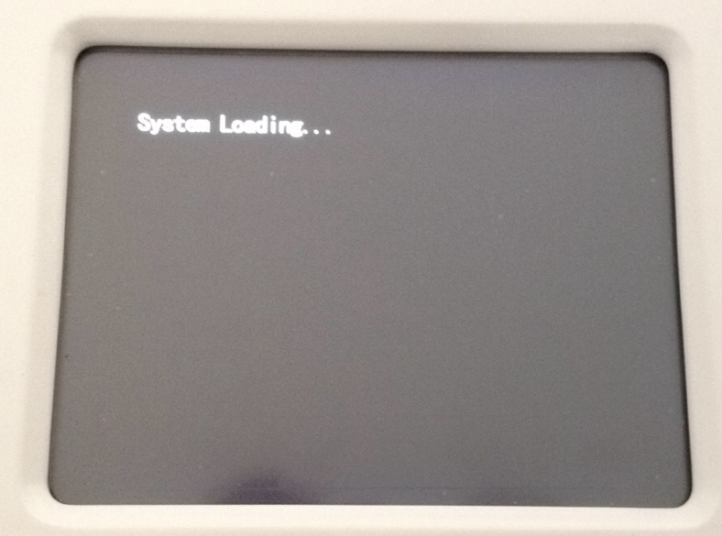
2. Then next screen. This screen saved for add customers logo. If no special requirements, there will be logo.
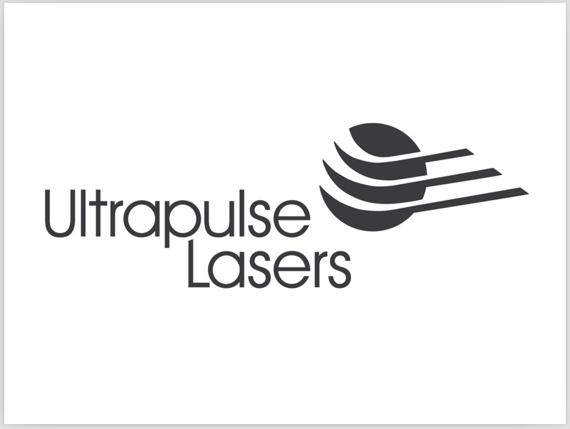
3. Click the above screen, we are in:
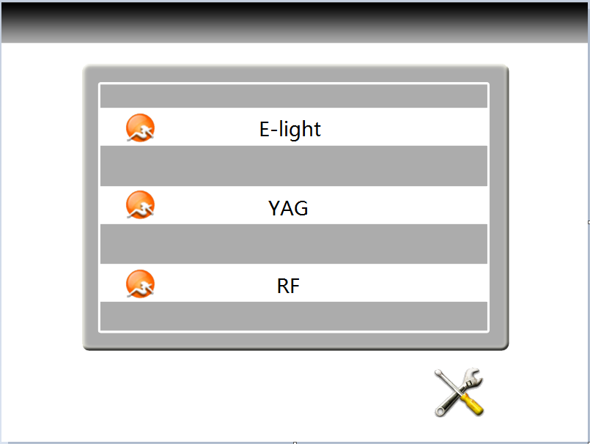
Click E-light, we go to:
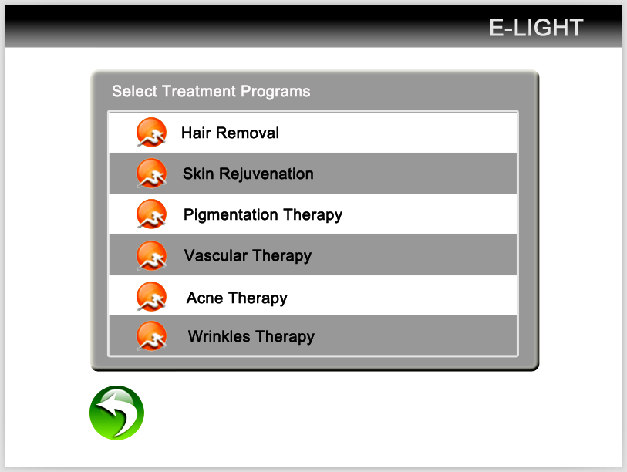
So you can select any function you want. Let’s take Hair Removal for an example. Click Hair removal on the above screen. Here we go:
Current treatment patterns

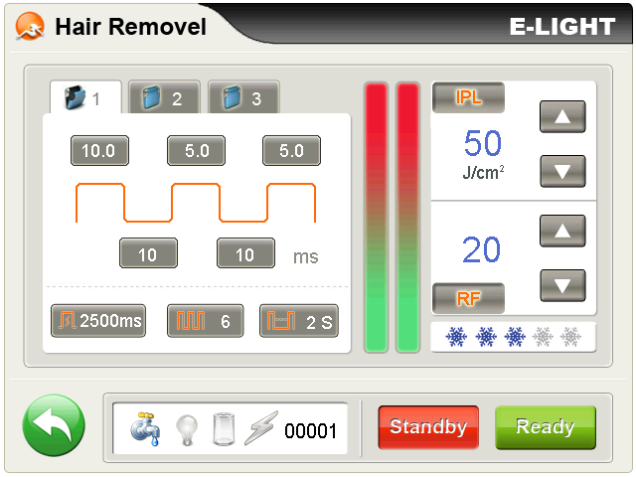
Ready /standby/
Return key
IPLenergy adjustment
Therapy parameter set
Head cooling temperature selection coolingtemperature selection
Status notification
Treatment records

RFenergy regulation

At this moment, please click the snowflakes to full level and just let the machine on there for about 3-5 minutes. Then touch the contact crystal to feel whether or not the Contact cooling is good. If it is very cold, it is OK. If not cold, please don’t let the handle shot flashes. Just contact us.

Introduction of the screen:
Settings Storage: to store a group of personalized parameters. 3 files in each application.
Pulse number: it is seepage force. More number, stronger seepage force.
Return: to the screen to select functions
Flash interval：To adjust the discharge interval, the adjusting extension is 1~4S, you can touch different figure. It the interval time bewteen the two adjacent flashes if keep pressing the switch on the handle.
IPL energy adjustment: to adjust the output energy of the light head. The adjusting extension is from 1 to 50 J/cm2. It can be changed during your treatment through clicking “△or▽”, “△”means up while “▽”means down.
Contact cooling level: to adjust the amount of snowflake from the left to right
The first pulse width: to adjust the first pulse width, the pulse width is the single pulse which be used, otherwise the first pulse width is the pulse width while many pulses be used. The adjusting extension is from 1 to 10ms by 0.1ms step in.
The first pulse duration: to adjust the first pulse width
The first pulse interval: to adjust the stay time between the first pulse and the second pulse, the adjusting extension is from 1 to 100ms by 1ms steps in.
The second pulse duration: to adjust the second pulse width, it will not display when single pulse be used. The adjusting extension is from 1 to 10 ms by 0.1ms step in.
The second pulse interval: to adjust the stay time between the second pulse and the third pulse, it will not display when single pulse be used, the adjusting extension is from 1 to 100ms by 1ms steps in.
The third pulse duration: to adjust the pulse width between the third and the fourth, it will not display when the single pulse be used, the adjusting extension is from 1 to 5ms by 0.1ms step in.
The treatment parameter can be changed, and you can adjust the parameter on the pulse wave pattern. The folder should be clicked again for saving the parameter after you input the needed number. The number will not be changed if the number is too big.

Sketch map of the pulse inputting
The second pulse width
The third pulse width
The first pulse width
The first pulse

The first pulse interval
The second pulse interval
Discharge interval
RF delay

When you finish changing one value on the screen, you must click the value again to confirm it. Then you can go on changing other values.
RF: regulate RF output energy, in the process of regulation,
Energy display window shows the current output value of energy, range from 1~20, this setting can be directly regulated
In the course of treatment, "△ or▽" adjust ", △" key to the increase, "▽" key to the reduce, hold down the "△or▽" key can be quickly adjusted output energy;
Please read the document of “Recommendation of E-light Settings” for reference.

When all the settings are ready, click Ready. You can hear PA. And at the same time the light in the handle is on.

Operation

1. Shave the hair
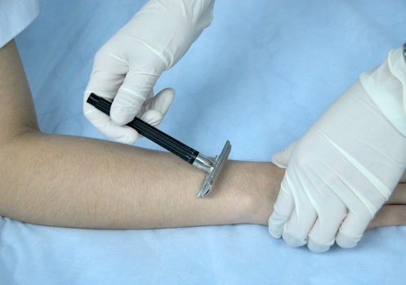

Daub ultrasonic Gel on the skin in 1-2mm thick.
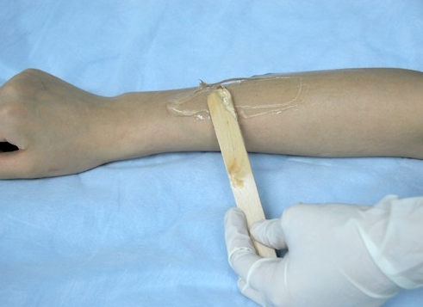

Please pay attention the way of handle during the treatment.

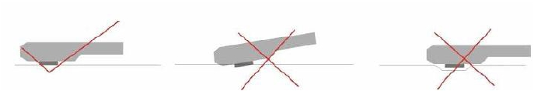
- Smear gel on the skin about 2 to 3 mm thickness before treating.
- Start the machine, processing step by step and adjust the suitable parametre.
- While exerting light pressure, approximate the treatment head perpendicularly over the treatment area. Ensure both metal slices of the head touch the skin naturally at the same time during treatment, If only one side metal slice touch the skin, it can be easily burnt skin. See above picture (1)Then can press the red bottoms to treatment. Before the treatment head leave the skin, please loose the red buttom first then treatment head can be off the skin.
- When the skin is in red after operation, coat the cool gel till the red is die out. Do not wash with water.

- Principles adjusting of parameters.
The white skin and lighter Skin | 1.Increase the power engery
The white skin and lighter Skin | 2.Decrease the pluse delay=(pluse interval) more cooling
The daker skin | 1. Decrease the power energy
The daker skin | 2. Increase the pulse delay ( allow more cooling)
The lighter the hair /pigments | 1.Increase the power engery
The lighter the hair /pigments | 2. Decrease the pluse delay= ( pluse interval)
The darker the hair/ pigment lesion | 1. Decrease the power engery
The darker the hair/ pigment lesion | 2.Increase the pluse delay= (pluse interval) more cooling
Fine Blood Vessels ( vascular lesion) | 1.Increase the power engery
Fine Blood Vessels ( vascular lesion) | 2. Decrease the pluse delay= ( pluse interval)
Thick Blood vessels | 1. Decrease the power engery
Thick Blood vessels | 2. Increase the pluse delay= ( pluse interval)cool more
The smaller the target size / lesion ( vascular) | 1.Decrease pulse delay
The larger the target size/ lesion ( vascular) | 1. Increase pulse delay ( allow more cooling )
Bony prominences (forehead, molar area, shin, bikini) | 1. Decrease the power energy

Chapter 5 How to use E-light?
Choose suitable pulse number, pulse width and pulse delay time, and set up the energy from low to high, meantime observe the color change of the skin. It is OK when the skin becomes a little red temporarily. Setting parameter is very important, which should be different according to different patients. Parameters should be adjusted in accordance with skin reflection during the treatment. The principle is as the following:
- The thicker skin and the pathological skin spread deeper need longer pulse width and higher energy.
- The darker, thinner skin is, the more sensitive skin is, and the lower energy should be used.
- When to operate on the part with less subcutaneous tissue, low energy should be used at first. With more times of treatment, properly enhance 1-2J/cm².

Management on the Skin Before and After Treatment
The hairs on the surface of skin should be shaved before the hair removal operating. And the couplant, like cold gel, should be daubed averagely on the skin. Cold compress with cold towels on the skin in 20-30 minutes after a treatment is better to ease pain and inflammation. In this situation, the aloe vera gel can be daubed to make recovery. During operation, the using of SPF15-30 sunscreen cream is suggested for against sun burnt. Also having vitaminB₁ could reduce the sensitivity of skin to light. The photonasty medicine and food (like celery, leek, caraway etc.) should be prohibited. The person with sensitive skin is prohibited to eat food that may cause skin allergy. Dryness of skin may be happened among part of patients, because absorbing capability of skin is getting stronger and body metabolism is getting faster after operating. So the complementarity of water and nutrition by skincare is necessary after operation. For thorough effect, the pigment that related to incretion should be treated with matching medicines.
Treatment Period
(The treatment period as follow is suitable for all therapy programs)
Each treatment lasts 20 minutes. The interval of every 2 treatments is 3 weeks. 5-6 treatments are a period. Why there are so many treatments? It is to reduce secondary reaction while to gradually beautify skin. In addition, we can start our work and life soon after a treatment with IPL, which is in accord with modern life. Treatment time and times are up to the size and degree of pathological area. Each treatment produces remarkable improvement.
Complicating disease
Seldom complicating diseases arise under the normal operation .The most familiar complicating disease is temporary rubeosis on skin, which needs no cure and would become normal in several hours after a treatment. Water blister, scab or purpura may appear on the treatment area of a very few of patients after a treatment, which is caused by overhigh energy or repeated overlapping of light spots. The area of water blister, scab or purpura should be kept dry and clean and it will disappear in 2 weeks. Because intense light sensibility for different people is different, pigmentation may be caused on a very few of patients. The pigmentation would be absorbed by our body in 3-9 months. Meantime, patients with pigmentation should try not to be under the sun for a long time and can have vitamin C and vitamin E to accelerate color metabolism. Part of treatment area, when a treatment is on, may feel like being shot by a rubber band. Most of the patients can bear it. No need to use anesthesia. For those who are sensitive in pain, narcotic can be sprayed on the treatment part before treatment.

Chapter 6 Taboo Instructions
  - Taboo
The apparatus cannot be used on people as follows:
    - Pregnant woman, people with hypertension, heart disease or diabetes;
    - People with photoallergy;
    - Not be used on the open wound;
    - People cannot be exposed under intense light;
    - Female in menses;
    - People who are using shall stop using the products getting effect instantly for 1-3 months before the operation by this apparatus.
  - 【Notice】
        - There is dangerous high voltage, please keep all faceplates and cover boards close;
        - The treatment head should be on the pothook when not in use;
        - The treatment head shoots intense pulsed light. Please keep directing it only at operating part;
        - Confirming that all operators and patients who may be exposed under the intense light are taking safety measures (no matter the light shoots from the treatment head or is reflected). All operators shall wear goggle provided by our company;
        - Never look directly at the intense light even wearing goggle.
  - 【Warning】
If an operating part receives superfluous light, it may cause heat injury, and then tissue may be hyperplastic and (or) atrophic and (or) pigments appear on the skin.

Chapter 7 Introduction of E-light

Concept of IPL
IPL skin rejuvenation is an innovational technology, which can cure various benign pathological changes of skin, such as age pigment of cuticle scar, birthmark, inaesthetic vein or blotch, and remove unwanted hair. To achieve satisfying and extraordinary effect, the apparatus provides safe and nonintervention method to suit different condition of skin, which is called IPL skin rejuvenation.
- Principle of Treatment
  - Biological Stimulation
Actinism, produced by Intense Pulsed Light operating on the actinic skin, makes the structure of molecules in the collagen fibers and the elastic fibers in the dermis layer change to restore original elasticity of skin. Besides, photothermy produced by above operation boosts blood vessel function, improves the circulation, so as to achieve dispel wrinkles and shrink pores.
  - Pyrolysis
With Intense Pulsed Light operating on the skin, for reason that the pigment agglomerate pathological tissue is much more than that in normal skin tissue, the temperature after absorbing light is higher than that of normal skin. The temperature difference blocks out the pathological blood vessel leading to cracking and decomposition into fragment, part of which is raised from the cuticle, and the other part will be decomposed into small particles, which can be swallowed by macrophage and discharged out of human body with the lymphatic system. Normal skin will not be hurt, because normal skin tissue absorbs little light energy.
  - Remove hair
Intense Pulsed Light operates on hair nipple and acts on pigment therein without any impact on its hair follicles or sweat glands. The cycle of a hair is divided into three periods: growing period, maturity period and dormant period. The growing hair in a can be dispelled completely once (Medically, a kind of small villus hair, which is white and not harmful to beauty, is called Juemao in Chinese)
- Sphere of Application
  - Speckle: chloasma, sunburn, butterfly rash, gravidity speckle, lead and hydrargyrism toxicosis speckle, skin changing speckle, age pigment;
  - Facial vascular lesions (Telangiectasis): threadlike facial vascular lesions (Telangiectasis), red face;
  - Skin rejuvenation: whiten skin, dispel yellow, shrink pore, dispel wrinkle, red face caused by honey layer becoming thin after skin changing;
  - Hair Removal: remove unwanted hair;
Chapter 8 Consumers’ manual

- Safety of IPL
IPL skin rejuvenation & hair removal apparatus is high-tech medical equipment, which safely dispels all kinds of facial flaws and unwanted hair on any part of human body. As long as an employee after training appropriately operates and maintains the apparatus, it is safe to operate. Security information in this Chapter can be understood completely by all operators or other staff or adjuvants. And the most important thing is to consider the safety for patients, operators as well as the other staff. Security is the first item considered in designing the IPL skin rejuvenation & hair removal apparatus.
Part of its security measures is as follows:
- Self-inspection system is activated instantly when the apparatus is turned on and the system will monitor the circuit continuously in the operation of the apparatus;
- Filter / light guiding crystal are used and transmitted onto skin. Impulse light can only shoot from the front of the light guiding crystal;
- Independent safety circuit can be cut off when the intense light is too strong;
- Using the red emergency switch to quickly cut off power supply if need;
- Using the key switch, the apparatus can only be turned on by the appointed person;
- High-quality molded shell is to prevent electrical leakage caused harm to person.
【Warning】
Any wrong operation of intense light electropult can bring harm to a person. Our product may generate high voltage. Every operator of intense light electropult shall keep on the guard and take necessary measures according to this brochure.
Safety of patients: safety of patients mainly relies on bridle-wise physician and appropriate disposal therapy room. Patients’ accomplishment is also important. They shall learn the principle of treatment. Patients’ eyes shall be protected effectively when receiving intense light treatment.
Safety of operators: operators may contact intense light in operation. Protection against corresponding wavelength shall be taken, that is, operators shall wear intense light goggles.
Treatment room: that intense light is using shall be marked remarkably.
【Primary Warning】
To guarantee safely use of the apparatus, prevention measures shall be taken. Please read advises as follows:
- Only technicians authorized by can examine and repair the apparatus, especially for the inside of the apparatus, including inside regulation for electricity source, optics organ and intense light head and so on. Please be advised that there is high voltage inside the apparatus;
- Voltage rating shall accord with that in your country (220V/108V or 220V/330V);
- The apparatus cannot be maintained unless it is off and power supply is off. Maintenance with electricity on may cause harm to human body or destroy the apparatus;
- Light guiding crystal shall keep clean. Coupling glue shall not get into inside light head;
- Don’t turn the apparatus on when light head makes water. If it is on in this situation, turn it off as soon as possible.
【Warning of Intense Light】
- Intense light may injure eyes and bring fire. All necessary safety measures shall be taken when using the apparatus;
- Superfluous light may bring heat injury to skin and then cause hyperplasia or unwonted pigment;
- Never look straight at intense light from the light head even wearing goggles;
- Don’t direct the light head to the air and shoot. The treatment head shall be put onto the pothook if not used and it shall be pointed at operation part when used.
- 【Safety of Electric and Mechanism】
      - Keep all the faceplate and cover board close, or danger may arise;
      - There is high voltage inside the apparatus, which may still exist on some elements even when electricity is off. Therefore, nobody can remove the cover board barring technicians sent by our company;
      - When maintaining the apparatus, don’t turn the power on, don’t remove the cover board, don’t keep it unattended;
      - The apparatus is more than 40 kg. Bodily injury may arise if moving it in a wrong manner. It has a good balance and is mobile, but shall only in carefulness and slowness way. Especially, don’t move the apparatus while the treatment head is in hand;
      - Land cord of the three-cord power supply of this apparatus connects to the land, which is very important for safety.
【Fireproofing】
- An object heats up while absorbing light energy. Effective measures shall be taken to prevent from inflaming tinder inside and near the treatment area;
- Tinder, such as alcohol or acetone shall not be used when disposing skin before surgical operation. Soapy water or medical distilled water can be used if necessary;
- If treatment head or any other parts of this apparatus are disinfected with alcohol, they shall not be used before they are complete dry.
【System Fire】
- The apparatus is equipped with some safety devices, whose position and how to work shall be known by all staff in operating room;
- Key switch: it is used to turn on and off the power supply. Only the keys our company provides can be used on the apparatus;
- Emergency switch: it is like a red mushroom and can turn on and off the apparatus in an emergency. When it is down, the power is cut off instantly no matter what status the apparatus is in. It will be up when to turn it deasil, or the apparatus is still power-down.
[Self-inspection]
When the apparatus is power on, the system circuit will starts self-inspection. In this situation, keep the apparatus running in proper motion 5 minutes, and then take the next step.
[Apparatus Level]
- Electric shock protection: level one, level BF;
- Antiseptic liquid: common;
- The apparatus shall not be used under the environment of mixture of inflammable anesthetic and air or laughing gas;
- Operation mode: successive
[Listing of Apparatus]
The apparatus listing is as follows:
A. Mainframe one
B. Standard treatment head of intense light one
C. Special goggle two
D. Manual one
E. Water pipe one
F. Power core one
3, [Installation Requirement]
Checking whether the spot to arrange for the apparatus accords with the requirement stated in this section before unpacking the apparatus’ package;
- Requirements for electric
- Voltage rating will have been set according with that of the location where the apparatus will be arranged. Single-phase 230Vac±10%,16A, 50/60Hz.
- Land cord (yellow/green) in the power cord connects the apparatus with the land, which is very important for safety;
- Input power shall not transients; current shall not get surge. Therefore, the apparatus cannot share its transmission line with elevator shaft, air condition system or high-power motor and so on. Our company recommends that the apparatus should use separate power supply and separate air switch;
- 6A breaker, the main protecting device, is equipped. The power supply is off instantly while the breaker is broken.
- Requirements for Environment
    - Air quality: there should not be corrosive particles (e.g acid), which may damage the surface of wiring, optical components of electrical components. Dust should be as little as possible in the air. Dust particles can absorb light energy and metal particles may damage electrical components;
    - Temperature: indoor temperature should be maintained at 20 ℃ -25 ℃, and the relative humidity cannot exceed 80%. When the apparatus works for excessively long hours, it distributes 200 W quantity of heat. Therefore, an air conditioning had better be installed indoors to reduce the indoor temperature;
- Remotion
When to remove the apparatus, please take the steps as follows:
    - Cut off the power cord;
    - Put the treatment head onto the pothook;
    - Loose the truckle brake;
    - Slowly draw and push the handle on the apparatus. Never push the apparatus forcibly, or inside parts may be broken due to exquisite shake.
[Installation] Under the supervision of our company’s technician
Operation and Technique
A. Operation flow
      - Confirming the treatment time and ask the patient to fill the register, and then clean his/her face;
      - After cleaning face, cover the patient eyes with a humid cotton sheet or paper towel, turn on the apparatus and confirm the water circulation is in a right way;
      - Cleanly shave off the hair on treatment part; if shrink pores, clean the pores firstly;
      - Smear condensation glue about 2mm in thickness on the patient’s either side of his/her face; adjust parameters in proper value;
      - After adjustment, hold light head, which should be downwards; shoot in the air two times; have an experiment on normal skin to see whether there is change and ask for the patient’s feelings;
      - If treatment part does not become red and there is no feeling of heat and sting, increase the energy. The increased value shall not be more than 2J every time. Shooting the light two times every time after adjusting the energy and one light spot should be lapped at the location of 1/3 of the other light spot. In this situation, it is normal that the treatment part is reddish for 3-5 minutes. It is at the best if the patient feels stinging and heated.
      - Operating on the two cheeks firstly; when it is the turn for forehead and circumference of mouth, the energy value should be reduced by 10%. If canthus dose not become red when dispelling wrinkles, do it again 2-3 times;
      - Confirm the effect after the first operation. If not satisfying, another 1-2 operations can be done after the red and heat fade away, and then turn the apparatus off;
      - If do breasts enlarging, only make them become reddish, sting and heated. It is normal if the breasts feel swelling pain, just like development in adolescence after operation;
      - Keep the condensation glue on face for 20 minutes and then wash it away;
      - Fill operation parameters and then ask the patient for signature.
We can adjust all parameters on this interface. When the parameters we need are ready, operation can start.

Chapter 9 Clinic Application Guide
  - Outstanding features of IPL skin rejuvenation technology:
    - Whole face treatment to improve the skin on face wholly;
    - Need no shutdown or rest;
    - Short treatment time-only 15-20 minutes every time;
    - No side effect.
  - How the treatment with IPL skin rejuvenation goes:
Normally, condensation glue shall be smeared onto the treatment part and the operator shall wear deep-color goggle to guard against intense light 10-30 minutes before the treatment. Then the treatment can be on. Put the light guiding crystal of the treatment head onto the treatment part and shoot the pulse light. The patient may feel slight being nipped, just like being struck gently by elastic. It needs not anaesthesia. The whole period of treatment includes 4-6 treatments in order to achieve the best effect, generate the least side effect and get satisfaction. Each treatment takes 15-20 minutes.
  - How many treatments shall be taken to achieve satisfying effect?
The times of treatment is subject to the size and pathological degree of treatment part. Normally, the whole period of treatment includes 4-6 treatments. Remarkable improvement can be seen after each treatment.
  - Why repeated treatments are required?
The purpose of dividing the whole treatment into several small treatments is to lower the danger of side effect while the skin is improved. The most important thing is that patients need not to leave from work. They can go to work immediately after the treatment. That is the treatment mode that modern people are seeking.
  - Is IPL skin rejuvenation & hair removal safe or will it hurt skin?
This technology is a method of non-exfoliation. It provides non-interposition type to adapt different skin. Therefore, it is safe and will not cause any damage to skin.
  - Is nurse required for skin after a treatment?
No special nurse is required. But insolation and irradiation by ultraviolet radiation shall be avoided in 24 hours. The interval between every two treatments is 21-45. The improvement of the whole face can be seen after a treatment. All facial flaws, enlarged pores, matted skin and other abnormal status caused by insolation and light aging can be improved remarkably or removed. The IPL skin rejuvenation can also improve skin’s deep level to make the skin smooth and rejuvenated and can be used on neck, breasts and other parts of human body.
  - What differences between the skin rejuvenation technology and traditional technology?
The techniques have seen great changes over the past decade. In the beginning, the grinding way and chemical deep-seated exuviations were use, then laser deep-level wrinkle dispelling. Although the methods above had a certain effect on some parts of skin light aging, patients usually needed a rest from work and oppressive pain had to be suffered. The potential side effect and shutdown brought a loss to patients’ revenue.
  - Features of IPL:
At present, some types of laser can be used on cure brown splash. Some others can be used for brown splash and dispelling facial wrinkles, but there is no other technique which can achieve the effect used by IPL skin rejuvenation, which can improve pathological skin and the skin’s structure on the premise that there is no disturbance on the busy urbanism. IPL can cure the whole face to bring much better effect than common method. The technique makes skin improved gradually and remarkably only in 4 months-5-6 treatments. Patients and beauticians can get great satisfaction with very low risk.
  - Can IPL remove hair forever? Is IPL treatment affects perspiration negatively?
Pulse light of special spectral coverage delivered by the apparatus can penetrate skin and reach the root of hair follicle directly. Melanocyte in hair follicle absorbs the light with specific wavelength and makes hair nipples generate heat. In this way, hair nipples are broken selectively. Accordingly, hair is removed and skin is rejuvenated while there is no damage to ambient tissue.
For reason that there is a space between sweat gland and hair follicle and sweat gland has no melanocyte therein. Therefore, sweat gland cannot be hurt and perspiration is not affected negatively.
  - Will the pathological changes recrudesce?
Pathological changes of transmissibility will not recrudesce, i.e. freckle and facial vascular lesions (Telangiectasis) of transmissibility; pathological changes caused by maladjusted incretion may recrudesce, which needs patients to improve their diet structure and law of life. Unhairing is permanent.

Chapter 10 Maintenance Manual
Daily Maintenance
[Notice] Our customers can only take the steps stated in this chapter for maintenance. Only technicians authorized by our company shall make other repairs.
【Caution】
- The apparatus shall be turned off and the power supply shall be cut off. Maintenance with electricity on may injure both of the user and the apparatus;
- Cleaning the surface: The apparatus shall be cleaned every time. Wet soft cloth or mild scour may be used to wipe the surface of the whole apparatus;
- Cleaning the light guiding crystal: Keep the light guiding crystal clean all the time. It shall be cleaned every time after using it. When to clean it, dry it with clean soft cloth firstly; secondly, clean it with soft cloth dipping alcohol. At last, wait for its dryness or wipe it with saline water;
- Water: Water in the system shall be changed once a month. It must be purifying water or distilled water;
- Energy adjustment;
- Steps for changing the treatment head:
  - Turn off the system switch and cut off the electricity cord to avoid damaging the apparatus;
  - Open the small square cover at the backside of the apparatus;
  - Loose coupling of treatment head;
  - Take treatment head out;
  - Tightly connect a new treatment head with the apparatus;
  - Restart the apparatus;
  - The new treatment head can be used;
  - Please contact the engineering department of our company if you have any questions.
Part of its security measures is as follows:
  - Self-inspection system is activated instantly when the apparatus is turned on and the system will monitor the circuit continuously in the operation of the apparatus;
  - Filter / light guiding crystal are used and transmitted onto skin. Impulse light can only shoot from the front of the light guiding crystal;
  - Independent safety circuit can be cut off when the intense light is too strong;
  - Using the red emergency switch to quickly cut off power supply if need;
  - Using the key switch, the apparatus can only be turned on by the appointed person;
  - High-quality molded shell is to prevent electrical leakage caused harm to person.
【Warning】
Any intense light device and harm the people if you operate improper. The equipment can exert high voltage, so people must pay attention when operating the device and take the necessary protection measures.
Sufferer: The safety of the sufferer depends on the high qualified director, and the operating room which decorates properly. The cultural quality of the sufferer is also important, they must know well the treatment principle, and the eyes of them should be protected.
Operator: The operator may contact with high-intension light, and she must wear special safety glasses.
Operating room: You must paste the notice that the high-intension light is working.
【Main Warning】In order to assure the safety of equipment, you must read the warning items following:
- Anyone mustn’t examine this apparatus except the technician who has been authorized by ESC. Attention that dangerous high-voltage inside the machine.
- Make sure that the specified voltage in accordance with the voltage in your own country.
- You can maintain this machine only after you turn off the machine and power-line. It can make personal and equipment damaged.
- The light head should keep clear and prevent the gule from permeating into the light head.
- You must turn off the machine if you find the light head seeping water.
【Warning about Intense Light】
- The intense light can hurt the eyes can cause fire, so you must take the protection measures.
- Radiating excessive light to the cure part of the body can damage the skin and make the usual pigment increase.
- You can’t see the light directly.
- Don’t radiate the light to the skin. You should put the head on the hook hitch.
- The safety of electricity and machinery
    - Keep both panel board and blind flange closed. It’s dangerous if you open the blind flange.
    - There is still the rest electricity even if you disconnect the mains lead, so you can’t take apart the machine except the technician.
    - You can’t open the electricity when maintain the equipment.
    - The equipment weight more than 40 kilograms. You must pay attention when move it. Don’t pull the machine by light head.
    - It is important for the earth wire to touch the ground.
【Prevent fire】
  - The temperature becomes high if object absorb the light, so we must take measure to decrease the number of the inflammable material.
  - Don’t use the inflammable materials, such as ethyl alcohol. If necessary, please use the soap-suds and distilled water.
  - The light head must parch when use it.
【System fire】
  - The equipment has some safety device; all the operators must know the instruction manual.
  - Key switch: The function of the key is to turn on or turn off the current source; all the keys must be provided by our company.
  - Hurry-up switch: The red mushroom switch can turn off the source. It cut down the current whatever condition it should be. Turn it in clockwise direction and the equipment can work again.
Electric shock protection: class one and class BF
Anti-corrosion: common
Don’t use the machine in the environment with flammable anesthetic and the mixture of gas and nitric oxide.
Operation way: continuation

Chapter 11 Knowledge about Skin
  - More Advantages. It can improve various skin flaws:
The treatment mode of IPL has breached the limit of traditional partial focus treatment, which can cure the whole face. The E-light apparatus can also cure the diseases as follows: capillary vessel expanding, erythema, pigment, petty wrinkle, sunburn, brown splash, enlarged pores, whiten skin. The treatment results show that over 75% of skin of 49% of patients has been improved. Facial erythema (75% of patients) and capillary vessel expanding (49% of patients) have been improved. The improving rate of wrinkle of 73% of patients has reached 25%, wherein the improving rate of 36% of patients have reached more than 50% and the improving rate of facial wrinkle and enlarged pores of 76% of patients has reached over 50%. In clinic reflections, skin structure, petty wrinkle, atactic pigment, enlarged pores and capillary vessel expending of all patients are improved.
2. Treatment on the whole face to improve skin’s character in order to resume skin’s flexibility:
New collagenous fibre produces smooth structure: pores become large, petty lines and wrinkles become less and can be reduced to utmost-to make skin more flexible.
3. Excellent results after 14 months and positive appraisal from patients.
Many treatment cases show that the long-time data of treatment with IPL technology is 14-18 months of patients with facial erythema and red face after treatment. The status of 80% of patients is the same as that after their last treatments. Few people get purpura edema. Most people’s convalescence is 1-5 days and two treatments with an interval of 21-45 day leads to better curative effect. There is no report about scars in all of cases. The IPL technology indeed provides safe treatment of nonintervention and non-exfoliation for people with love of beauty and is accepted by general suffers.
4. E-Light Skin Rejuvenation is a nontraumatic technology:
Traditional skin rejuvenation technology adopts the grinding way and chemical deep-seated exuviations. Then laser dispelling deep-seated winkles method followed. Although these methods have a certain remedy for some parts of skin aging treatment, patients usually need a rest from work and oppressive pain is accompanied. Potential side effect and shutdown seriously disturbs normal life and work. Photon skin rejuvenation adopts the treatment of nonintervention and non-exfoliation to rejuvenate skin with low-density energy. Accordingly, this technique brings no pain, no side effect, no shutdown and wins higher satisfaction of patients.
5. What is freckle?
It is a kind of small brown or filemot pigmentation on face and is autosomal dominant inheritance, which is serious especially in summer. The development of pathological changes is related to solarization. Freckle occurs mostly to women and emerges in childhood after the age of 6-7 usually. It becomes obvious in youth. Skin lesion due to solarization gets serious in summer but mitigatory in winter. Skin lesion is canary or filemot or brown splash, which is rotundity or elliptical or irregularly shaped. Freckle is concentrated mainly on face, especially from eyes to cheekbones.
6. What is chloasma?
It has another three names, which are butterfly spot, cloasma hepaticum and soot-black macules in physic. It is common and a frequently encountered disease for women. The incidence of the disease becomes more obviously and seriously for the past few years.
In the beginning, chloasmas are in light color. They may be multiple but gradually syncretize into spot in different sizes and shapes with clear borderline. They intersperse symmetrically on exposure parts, usually on cheekbones, forehead and cheeks. They have no subjective symptom.
Chloasma has three types according to their location: it is called superficial type one if it locates on cuticle, shallow-seated type if deep in cuticle and deep-seated type if in corium. This classification is mainly related to treatment. The deeper the location is, the longer the treatment time is and the more difficult the treatment is.
Aetiological agent is very complicated. It may occur to healthy women from youthhood to climacteric. The incidence rate of chloasma caused by oral contraceptive reaches over 80%. Some chronic diseases, especially female diseases of reproductive system, such as menoxenia, adnexitis, acyesis, ovarian cyst and hysteromyoma, may cause chloasma. In addition, chloasma may be caused by other diseases, such as hepatopathy, chronic alcoholism, thyrotoxicosis, tuberculosis and viscera tumor. Many kinds of medicine may cause chloasma. It also can be induced and deepened by sunshine and hereditary factors, sleep disorder, psychic factor and so on are somewhat related to chlosama.
7. What is acne?
Acne is a familiar hair follicle thylacitis in youthhood. It is also called acne vulgaris and commonly referred to as whelk (Qingchundou in Chinese). Acne is usually found on face, sometimes looks like papilla, blain and so on. Sebum is often accompanied and overbrims. The pathogeny has not been clear yet but may be formed synthetically by various factors.
- Androgen-mediated lipid overflow - androgen and its metabolites, such as dual-oxygen copper and sulfuric acid dehydrogenation Cremaster epidermal-steroidal copper increase, which strengthens the activity of sebaceous gland. Secretion of patients with acne skin is higher than that of normal people.
- Funnel of hair follicle keratosis - acne patients’ keratosis of of hair follicle funnel boosts up and its epicyte becomes thick and dense, so it is difficult to drop off. It has not been clear yet why the keratosis of of hair follicle funnel boosts up, but it may be related to free fatty acids in the cortex. In addition, the amount sebum linoleic acid of patients with acne is less than normal, which might be another reason.
- Acne propionibacterium increases- acne propionibacterium belongs to anaerobic organism and is a resident bacterium. Why it increases may be related to funnel of hair follicle keratosis, sebum discharge blocking and relative anoxic environment.
- Inflammation - acne propionibacterium excrete dissolved lipase, which will decompose the triglyceride into glycerol and free fatty acids. Glycerol and free fatty acids further stimulate gland wall keratosis, so the adenovirus mouth is blocked. Experiments prove that carbon atoms containing 8-14 can penetrate hair follicle and goes into corium and then causes more obvious inflammation. In addition, acne propionibacterium can not only produce dissolved lipase but also prolease, hyaluronidase and some chemotactic factor activating complement, which all can bring inflammation of the hair follicle sebaceous gland and papilla, blain, nodules and so on.
- Acne caused by cosmetic – (a) improper cosmetics are used, i.e. people with oily skin use oily cosmetics, making the hair follicle mouth metabolism sluggish. Hair follicles are blocked by hard, dense keratose substance, which leads to expand, these keratose substance forms keratose bolt, plugging in the hair follicle mouth. Accordingly, acne arises. (b) Some cosmetics containing substance of particles, such as a great deal of superfine titanium pigment, whose particles are agglutinated with sebum or stroma. It is easy to plug holes of hair follicle and causes acne. And young people indulge in the cosmetic, making light acnes serious.
Moreover, inheritance may be an important factor causing acne, and orally taking medicine containing iodine, bromine, cortex steroid and so on can make acne more seriously.
8. Six inducements making skin dark and spotted
Specifically, inducement causing skin black and spotted mainly is:
- The arch-criminal-ultraviolet radiation;
- Some sensitive food, such as animal liver and kidney, oyster, shrimp, crab, legume, walnut seed, currant and so on;
- Drinking and smocking;
- Some diseases;
- Some medicine: quina, tranquillizer containing chlorpromazine;
- External cause: rubbing skin hard when having wash.
9. How wrinkle come?
Wrinkle is the result of skin aging. Wrinkle is synthetically formed by internal cause, external cause and other factors.
- Internal cause: in youth, skin is rich of moisture and all kinds of glands’ body fluid are excreted noticeably. Skin is at its best time at this time. Wrinkle is not easy to arise. However, wrinkle will come and temporarily exist if skin is of over hydropenia for reason that skin is not taken good care or diseases arise. If moisture is makeup to skin once, the temporary wrinkle will disappear. But in middle age, the horny layer’s ability of keeping moisture declines. Sebaceous gland is excreted less. Elastic fibers in corium are of denaturation and ruptured. Adipose layer decreases…. All these factors lead to skin’s change. Wrinkle is the symbol of skin aging, which can be seen with our naked eyes.
- External cause: skin is the surface layer, which receipts sunshine, wind, and dryness. These are all factors making more and deep wrinkles. We all know that people living on Qinghai-Tibet Plateau all have deep wrinkles on their faces. This is brought about by wind and sunshine. Ultraviolet radiation in sunshine is one of the reasons for skin aging and wrinkles. Therefore, people should prevent skin from being sunburned. Sunburn prevention and moisture keeping are both important.
In addition, too much make-up is a direct harm to skin. All cosmetics are chemical. Although some cosmetics adopt natural materials, synthetics, such as coloring matters and flavors are also used in their production. Therefore, make-up provides beauty temporarily. It also damages skin and causes wrinkles.
What should attract our attention is that some wrinkles on women’s face are caused by cortex steroids ointment used in external way, such as fludrocortisone ointment, triamcinolone acetonide ointment, compound dexamerhasone acetate ointment. These ointments lead to skin shrinking, thinning and wrinkles.
10. Four-step wrinkle prevention
Wrinkle can be divided into kinetic energy wrinkle and static energy wrinkle. Static energy wrinkle is a kind of wrinkle that can be seen even a person has no facial motion, i.e. part under eyes, at altercates. That is brought from skin aging and from cuticle and corium becoming thin. Kinetic energy wrinkle is a kind of wrinkle that can be seen when a person’s face has a motion, i.e. wrinkles on glabella, sides of eye tail and forehead. But winkles can be also caused if a person’s bodily form is thin with less subcutaneous fat.
According to external changes in different ages, wrinkle’ formation can be divided into four stages: a. Mild aging stage: at the age of about 28-25. Fundamentally no wrinkle can be seen;
b. intermediate aging stage: at the age of about 35-40. Kinetic energy wrinkle arises;
c. relative serious aging stage: at the age of about 50-60. Static energy wrinkle arises;
d. most serious aging staging: at the age of over 60-75. Obvious wrinkles and skin prolapse can be seen.
11. Wrinkle arisen rate of all ages
Wrinkle arisen rate of all ages is recorded in percent form as follows:
At the age of 18-29: wrinkles arise on 44% of women’ forehead
At the age of 30-39: wrinkles arise on 56% of women’s glabellas
At the age of 40-49: wrinkles arise under the eyes of 72% of women and on glabellas of 75% of women
At the age of 50-59: 65% of women have goosefoot lines and 60% have nose-chin veins.
12. How sensitive skin comes?
Is delicate skin easy to form sensitive skin?
No exactly. Sensitive skin is divided into congenital type and postnatal type. The former one is related to inheritance. It is usually sensitive skin. The later one is related to many factors, such as: a. environment, season alternation. Lines are caused by changes of humidity, air pollution and ultraviolet radiation; b. internal disease and incretion disorder, i.e. long-term disorder of stomach and intestines’ function; c. unbalanced nutrition and long-term innutrition; d. spirit, long-term instable spirit, high pressure and excessive blahs; e. medicament, i.e. skin may has dependency on medicine if keeping using punchy or steroids medicine; f. improper maintenance, i.e. skin is cleaned excessively using alkaline products, or excessively remove cutin.
13. How hypersusceptibility comes?
There are four factors that tend to bring and induce hypersusceptibility:
- Food: irritative food, such as seafood, pollen and capsicum and so on;
- Medication: eternal medicine, such as liniment, lintment; medicine, such as aspirin, anodyne, diuretic and so on;
- Cosmetics: alcohol, coloring matter, flavor, antiseptic and sun-screening agent, and hair dye, cold wave lotion and so on；
- Eyewinker: such as animal hair, leather goods, K gold, oil paint and so on.
14. Why sensitivity and hypersusceptibility occur?
Healthy skin has a layer of natural protective membrane-sebum membrane. In normal conditions, it contains about 5%-7% of axunge, 20%-30% of moisture, both of which are in subacidity. It can prevent not only moisture from excessive evaporation, but also ultraviolet and air pollution from hurting skin. Once sebum is damaged, moisture-keeping function will become weak, skins is getting dry, itch, even peels, and becomes weak in guarding against cold and hot and pressure. In this situation, we can see inflammation, red in some parts of skin. That is sensitivity.
Hypersusceptibility refers to that a series of reflection will arise when skin contacts anaphylactogen.
15. Characteristics of hypersusceptibility and sensitivity:
Characteristics of sensitive skin are: a. hair pores are closed and fine. The surface of skin is dry, coarse. Skin is thin, and capillary vessel and asymmetric rubeosis can be seen; b. dryness and itch tend to occur to surrounding of eyes, mouth margin, arthrosis and so on. c. many cosmetics and some medication lead to hypersusceptibility, which is marked by partial rubefaction, itch and anthema if not serious, and swelling, exuviations, many irritable pimples, water seepage and even exuviations in large area and fever heat on the whole body if it is serious.
16. Treatment of hypersusceptibility and sensitivity:
Words from exports:
- For sensitive skin, irritative food and herb cosmetic should not be eaten and used; no contact on hotness, alkali and electricity; do not rub skin excessively; avoid being irradiation by ultraviolet radiation and wash face with cold or warm water.
- Once hypersusceptibility occurs, we should go to find out why. We should keep away from anaphylactogen. Simultaneously, adjusting immunity and improving sensitive constitution through eliminating free radical.
If hypersusceptibility occurs during nursing:
  - Stop using cosmetics. Have a treatment if it is not serious and smear antianaphylaxis medication if it is serious, and stop using the medication at once when the disease straightens up. If it is very serious, go to hospital for a treatment.
  - Nursing order in beauty parlor can be improved. The order is: cleansing cream-skin lotion- cold spraying (B6 vitamin or antianaphylaxis essence can be added)- shiatsu on facial points- antianaphylaxis collagen face mask- cold compress-basic maintaining.

Chapter 12 Introduction of Laser Tattoo Removal system

From the following screen. Click YAG

We enter laser treatment screen
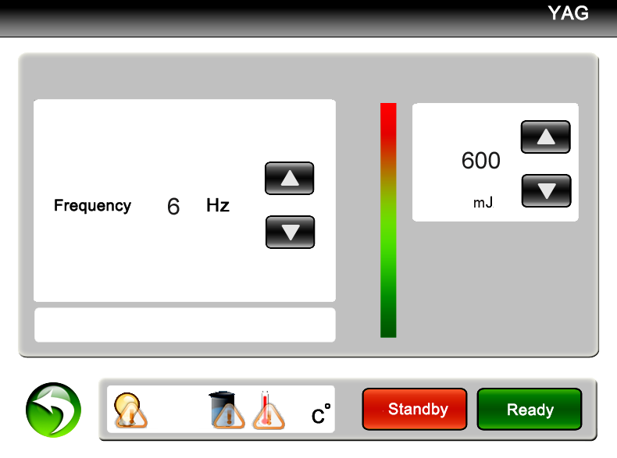
- Treatment principle:
Depending on the Q-Switched Nd, the instrument breaks pigment in injured tissue by means of high energy delivered instantly from laser. The principle of demolishment by laser: specific-wavelength laser gathers high energy instantly and shoots to penetrate cuticle in a cutty time (6 nm) and reaches injured tissue in order to break pigment into fragments. As a result, the pigment agglomerates expand in high speed because of heat and explode into particles instantly. Part of particles (in shallow cuticle) is discharged from the body and the other part (in deep tissue) is broken into grains small enough to be absorbed and digested by macrophage and removed out of the body by lymph system. Accordingly, the color of pigment in injured tissue fades and up to the color of normal skin. Since this specific wavelength can only be absorbed by pigment particles, no injury happens to normal skin and normal tissues.
- Application:
The sapphire Q-switch laser tattoo & eyebrow removal equipment can effectively cure pathological changes of endogenous and exogenous pigment formed by mixed pigment--pigment deposit cause by operative errors on dark embroider eyebrow, embroider lip, soak lip, embroider eye line, lip line, tattoo (including traumatic tattoo), allergy source pigment, such as black, blue, green, purple, brown and red color in freckles, cafe-au-lait spots, age pigment, black naevus, etc.
- Reference table of all kinds of treatment period of case history:

Time  Case | Treatment  times | Treatment intervals  (intervals of two treatments) | Remark  (requirements in treatments)
Tattoo | 1~4 | 30~45days | Good effect if blood oozing
Embroider eyebrow | 1~3 | 30~45 days | protect eyeball when shaving eyebrow
Embroider eyeline | 1~3 | 45~60days | protect eyeball when shaving eyebrow
Dyelip Soaklip  Embroiderlip | 1~3 | 30~45days | choose 532nm the light head
age pigment  Fleck | 1~4 | 30~45days | Good effect if blood oozing
Naevus  Birthmark | 3~7 | 30~45days | Good effect if blood oozing

Chapter 13 Safety Attentions
- Laser safety:
  - According to laser radicalization safety, laser eyebrow & tattoo removal equipment belong to the fourth laser product;
  - Laser is invisible infrared light, wherein, the 532nm laser is a light that is green, dazzling visible light. Accordingly, any operator shall wear a pair of goggles with wavelength range 200~1080nm;
  - The laser window is located at the bottom of the treatment head. Anyone must avoid radiation;
  - Anyone should never look directly at the bottom of the treatment head or any reflecting laser light;
  - Keep combustible and explosive stupefacient, liquid, gas (for example: ethanol aether laughing gas oxygen and so on away far from laser radiation area and defend measures should be taken;
  - Don’t irradiate laser to metal devices, or laser is reflected and is dangerous to anyone around;
  - No reflecting things worn, such as watch, necklace, bracelet, etc;
  - Must offer safety sound safeguard to sufferer’s eyes, when removal eye line, the worker must keep out sufferer’s eyeballs by gauze, the worker should have ophthalmic clinic experience and strict according to company training way.
  - Different pigment assimilate different laser, the choice of dosage must from small to big.
  - Our company advice you prepare special laser room and prepare air-condition or xerantic machine and paste treatment notice matter.
  - Notice: big facula relative lesser power density, small facula relative biggish power density.
Power density = power big or small / facula acreage
- Eye safety:
  - Any operator in operation area shall wear goggles (200—1080nm) and any sufferer’s eyes shall be protected strictly and effectively;
  - Never look directly at laser or reflected laser even wearing goggles;
  - Using gauze or eyelid plate to cover eyes, wearing goggles are all effective to protect sufferer’s eyes. Wherein, humid gauze to cover eyes is more effective, but treatment part should be dry;
  - The equipment should be off power when debugging laser or clean laser lens.
- Electric safety :
  - According to electric shock egis sort, the laser eyebrow and tattoo removal series belong to Ⅰ- B model general equipment.
  - Connect measure up international monomial three line electrical outlet, the spec 10A upwards.
  - Steady voltage.
  - After stop the machine, it inside still leave behind remnant voltage, so can’t optionally take apart machine.
- Carry safety :
  - The machine is portable equipment, move easy.
  - Must not hit the light head of treatment, because it has exact optics system.
  - Keep water pipe expedite and treatment handle should be packaged by sprung materials.
  - Before carrying, must take away apertured cover of water tank, instead of imperforate cover of water tank.

Chapter 14 using of the laser machine
- Notice when operating
    - Make sure the operation room clear when operator handles the equipment.
    - Operators must wear white or tint work clothes in order to reduce radiation to body.
    - The illumination of the operation room must strong enough in order to enlarge indoor occupants’ pupil.
    - Don’t use the specular reflection articles while you use the laser machine.
    - The operator must know about the diseases and symptoms of the sufferers and tell them the possible normal responses during and after operation.
    - Operators who are professional must keep the laser beam away from non-treated areas.
    - Operators must make sure the safe of the eyes of sufferer when treating the embroider eye line, because the harm to eye is irreversible.
- Installation procedure
⑴ To place: Place the equipment steadily in the operation room or treatment room which the temperature is between 22—28℃ and the humidity is below 10%.
⑵ To inject Water: Inject 600ml medical distilled water and pure water from the water injection hole on the top of the equipment. From the water hole you can see water level flat to the first heat dissipation hole which is in side of the crate, so called standard level.
⑶ To choose treatment light head and wear glasses: To choose the relevant light head according your need and tighten the light head follows the threads direction. 1064nm gets rid of black, blue and cyanine pigment, and 532nm gets rid of red, coffee and brown pigment.
⑷ To change the imperforation tank cap into perforated tank cap to make sure the water cycle normally.
⑸ To install: To connect the power supply line and food switch pedal in the condition that there is no endosmosis and external leakage.
a) To install food switch pedal: to make sure the orifice be tightened according to the clockwise.
b) To install the electric outlet: one side to connect the line to the tail of the machine, and the other side to connect to the three holes outlet.
（6）To electrify: You can insert the key right-lateral to the opening position, and whole of the machine electrify right away.
3. Operation methods
⑴ Operation methods for touching interface

Examination of waterflow
Waterflow is very important. If waterflow is bad, the handle is easy to be broken.
Step 1. After you add new water every time, let the handle hose and handle in lower level than the handle connector. It is easier for the water to run in.
Step 2. Then turn on the machine, let the machine run in 5-10 seconds. Turn off the machine.
Repeat Step 2 for 2-3 times.
Operation:
Step one: insert the key and right-lateral to the opening position. At that time whole of the machine electrify and you can hear the normal sound of the water cycle. (The red hurry-up switch must be lifted.) And now you must examine the water cycle in the water tank if there is water column inject.
You can go into next step if you make sure that the water cycle is normal.
Turn on the machine, see the screen as follows:

Click , go to next screen:

In this screen, there are two item need you to adjust: Frequency and Power.
Frequency is 1-6 adjustable. For a new hand, it is better to use 1-3 Hz. It is better not use 6 Hz, 1-5 Hz produces enough power for every shot.
Power is 300-1500 adjustable. Please try from 300.
Click or to raise or low the Frequency or Power.

Procedure to operate the laser
    - Adjust the Frequency and Power ready.
    - Click . You will hear a “click” from the machine.
    - Fix 1064nm tip(for blue, black, cyan) or 532nm(for colorful tattoos like red, coffee, brown..) tip on the handle.
    - Let the laser tip vertical to the tattoo area and the laser exit on the laser tip touches the tattoo area.
    - The laser will shoot when you press the Pedal switch. At this moment, you feel weak shots. Increase the distance between the laser exit and the tattoo slowly and you will find the energy focus when you hear “pa..pa..pa”. This distance is the strongest.
    - When you finish a treatment, please click to have the laser Standby. Then turn off the machine by key switch. It is not good to the laser if turning off the machine directly without .
Attention:
1. When the machine is on, the laser exit on the handle never towards to your eyes, or other people. The laser is harmful.
2. The operator should wear the protective glasses, and the patient should wear eyepatch.

If you want to learn more details about the Q-switch ND:YAG lasers, please finish the following Chapters.

Chapter 15 Operation of Laser Instrument

  - Notice
⑴first you should ask the customer if he\her is scar physique, if had changed skin, if he\her is allergic skin, if he\her is shaded eyebrow or removed eyebrow, tattoo by other ways. You should examine that if the treatment area already has scar, and you should tell the sufferer that maybe there is pigmentation some times later after you remove the pigment, and these pigment is caused by sunshine and he\her can get treatment one and a half months later.
⑵、the operator should tell the sufferer that may happened situation and treatment principle during the treatment using the 1064nm to treat the black and blue pigment in case the unnecessary bothers.
You can shave the eyebrow before removing the eyebrow with machine in order to examine the effect. We advise you that you should treat the big area tattoo and nevus little by little and time by time in case uncomfortable of the sufferer. You can also help the sufferer to build the confidence according to the contrast between before and after the operation.
⑶、There maybe the sound of the pigment breaking when you treat the deep tissue of the tattoo because of the strong absorption to laser energy with 1064nm. The tint color of the pigment can comes out the cuticle after absorbing the energy. Some people may have some drops of drain blood because of thin cuticle. In the first time treatment, the color of the tissue may become thin, but later the color may recover about ten minutes later. This kind of effect is normal. The function of digesting and transportation of the macrophage can continue long time, and the color can become thin during this period. We advise you take the second treatment one and a half months later of the first time. The eye is more sensitive, so it tears to influence the effect; generally we take two times to get into the effect.
⑷、The hair may exfoliated after operating as you remove black and blue pigment with 1064nm, but the new hair can tend to normal. There may ooze blood and tint edema in the treatment area. It will be normal if there is the feeling of itch and the tissue is a little hard. All these feeling will disappear in two weeks or about a month, and the time is different according to different people.
⑸、 Hemoglobin of the tissue absorbs certain wavelength of the 532nm when you remove brown, red pigment with 532nm. The surface of the skin irradiated by laser may turn white, so as to making the pigment drops and pigmentation.
(6)、The capillary may break and form congestion as absorbing the wavelength of 532nm, if serious can cause scab. But it is well in about 20-60 days according to different people.
⑺、The sufferer will be forbidden drawing eyebrow, bathing and touching in the blood oozing area, and avoid shinning in case causing pigmentation. If serious, the sufferer can take some medicine and erytheromycin ointment which external used followed by doctor. You also will not allowed to take pepper food and alcohol.
  - operation skill and technique
- demands before operation
- Cosmetologist should build file for customer in order to well know about the real disease and choose the needed energy; at the same time the cosmetologist should explain the advantages of laser machine in order to make the customer to relax and cooperate.
- Clean the treatment area, disinfect utensil, shave the eyebrow, and wipe affected part with physiological saline. You must pay attention that the affected part must be dry, and the treatment will be affected if there is water in the affected part.
- The worker should wear white clothes and relevant wavelength glasses. Keep the operation room clean and illumination is bright enough. You should keep the temperature is between 22 and 28℃, and avoid the laser irradiating non treatment area.
⑵ Demands during the operation
- the needed frequency during the operation
Adaptive disease | Best used frequency | Treatment Distance | Energy
Tattoo removal | 3--4Hz | 3—5cm | 500—600mj
Eyebrow removal | 2--3Hz | 1—2cm | 400—500mj
Eye line removal | 1--2Hz | 1—2cm | 400—500mj
Lip line removal | 3--4Hz | 2—3cm | 400—500mj
Spots and naevi removal | 3--4Hz | 3—5cm | 600—700mj
Birthmark removal | 3--4Hz | 3—5cm | 650—800mj
Notice: ① 1064nm gets rid of blue, black and cyanine pigment.
② 532nm gets rid of red, coffee and brown pigment.
③ the light head should form right angle with treatment area in order to reduce the energy losing. The light spots should fold and translation to a line when you remove eyebrow, eye line and lip line. You should remove the spot and naevus time by time in the little area. The treatment area should ooze blood when you treat the little area.
- operating technique introduction for different disease
- tattoo removal
- removing single blue and black eyebrow:
The operator chooses the needed energy according to the depth of the pigment and move slowly to the skin with light head so as to making the sufferer has a mentality reception process, at the same time the sufferer should close eyes when accepting the treatment. You should settle the light speed to 5Hz; the distance from light head to skin is one or two digit space distance. You may treat from the head or may from the tail of the eyebrow. You can take the second treatment if there is color restoration. The energy can add 20-40 and the light head can drive up 2-3 digit space distance in order to making the effect becomes well.
- shaded eyebrow removal ( the shaded eyebrow can be removed clearly 2 or 3 times)
You can settle the light speed is 3Hz and the energy can be settled according to the above form. First you can treat with 1064nm in 2-3 digit space distances, and then you can treat with 532nm in the second time. The brown pigment belongs to mixed pigment, so you should take more than two times, the period is from 45 to 90 days. You can choose different light head according to the left color.
② Eye line removal
The light speed can be settled to 5Hz, and the energy is settled to the lowest point. It is about 2-3digit space distance from light head to the treatment area, and the light will be seen as reference. The sufferer’s eyes should be protected with thick medical cloth. First you remove the sufferer’s lower eye line, and the sufferer should close his/her eyes, at the same time the eyeball looks up. The operator presses the cloth with index finger, and peels away the lower eyelid with middle finger. The light speed can be settled to 5Hz. When you remove the upper eye line the sufferer should close his/her eyes with eyeball down gaze. The operator presses the cloth with middle finger and pulls the eyelid with index finger. The light speed can be settled to 5Hz.
③ Lip line removal
The light speed can be settled to 5Hz, and the energy can be settled according to the reference form above. The distance from light head to the treatment area is 3-4 digit space. You can remove the black, coffee and deep red with 1064nm for the first time and then use 532nm for the second time. You can use 532nm to remove thin red, red, thin coffee and thin brown. You must pay attention that you accept the second treatment of removing lip line, soak lip and the lip’s tattoo only half one year.
The course of treatment is from 45 to 60 days until it is clear.
- Tattoo removal
The light speed can be settled to 3Hz/5Hz, and you can settle the energy according to the reference form above. The distance between light head to treatment area is 3 or 4 digit space. The effect will be best if there is blood oozing point. The light head of 1064nm gets rid of blue and black pigment while 532nm gets rid of red and coffee pigment. The course of treatment is from 45 to 90 days until it is clear.
- Speckle and naevi removal
The light speed can be settled to 3Hz/5Hz, and you can settle the energy according to the reference form above. The distance between light head to treatment area is 3 or 4 digit space. The effect will be best if there is blood oozing point. The light head of 532nm gets rid of red pigmentation while 1064nm gets rid of speckle and naevi. The course of treatment is from 15 to 30 days until it is clear.
- Birthmark and nevus of Ota removal
The light speed can be settled to 3Hz/5Hz, and you can settle the energy according to the reference form above. The distance between light head to treatment area is 3 or 4 digit space. The effect will be best if there is blood oozing point. The light head of 532nm gets rid of red pigmentation while 1064nm gets rid of birthmark. The course of treatment is from 45 to 90 days until it is clear.
⑶The reaction during the operation and recovery after the operation
The pigment of the lesion tissue is broken into gains small enough to be absorbed and digested by macrophage. Part of the particles which in the superficial is discharged from the body and the other part which in deep tissue is regularly permutated in superficial, so the tattoo can return in short time. It will be normal if part of the skin becomes red swelling, blister and even blood oozing because the black pigment absorbs the energy strongly when you treat the deep tattoo. The degree is different according to different people, and you can feel a little itch and hard of the tissue. Generally speaking, the uncomfortable will disappear in 3-7days, but it may take 1-3 months for some special constitution.
You will not be allowed to draw eyebrow, take shower and get sunshine after getting treatment. You also should change the bad dietary habit followed the doctor. You can’t take alcohol in 3-7days. We suggest that you should take antibiotic if blood too more and serious swelling after treatment. You can daub erythromycin ointment to help to heal in the recovery period.
⑷ the determinants for which pigment is different to dispel
  - The quality of the texture of the pigment, the pigment divided into plants pigment, mixture pigment, and chemical pigment. The plants pigment is dispelled easiest while the chemical pigment is most difficult to dispel. Generally, there are iron and lead in the mixture and chemical pigment, so it is different to remove.
  - The depth of the pigment. Generally speaking, the deeper of the pigment, the more difficult to remove. And it also takes many times to dispel. It will easy to dispel if the depth of the pigment is thin. The effects will not well if the pigment is chemical even the depth of the pigment is thin.
  - The different physique of people. The factors include age, skin, and body immunity and so on.
  - The knowledge collection of eye brow removal
⑴ The differences between the first and the second eye brow removal:
You should use the energy which near the focus energy. It is farther than the first time and the energy is bigger than the first time.
⑵ The reason that the coffee turns to blue and black:
It is normal reaction if the coffee turns to blue and black because the coffee is a mixture pigment which includes iron, lead ion, iron ion. And all these ion can produces pigmentation, so we advice you remove the pigment with 1064nm for the first time and then use 532nm.You can examine the effect half one month later. You can use 1064nm to remove if the color turns to blue, and use 532nm if it turns to red.
⑶Why does some red eyebrow have no reaction after removing?
The pigment does not belong to plant pigment but the chemical pigment, and the iron ion has reached in to derma, so it is difficult to remove. You should use the focus energy of 1064nm to break up the pigment until it appears the oozing blood, and then you remove it with 532nm.
⑷ How to remove the speckle of the face?
There are good effects on removing drought spot and butterfly speckle which caused by climate. The deep and hereditary speckles are difficult to remove while shallow and formed by acquired factors. You can use the focus energy to remove the senile plaque until it appears oozing blood. There are three treatment courses with 45 days as a interval period.
⑸ The treatment ways to remove naevi.
Using the focus energy to remove the naevi until it appears oozing blood.
(6)Can the scar constitution be removed?
A few people can be removed but the effect is not well. You should not use the focus energy, but to use the big facula and little energy.
⑺ Can the pregnant woman be removed the eyebrow?
It is not allowed to accept the eyebrow removal.
⑻ how to remove the red blood streak and what degree will be ok?
We don’t suggest that you remove the red blood streak, because the 532nm can absorb the hemoglobin in the blood. It can form the purpura to cause the operation fail.

Chapter 16 The Maintenance of Laser Instrument

1、Ordinary maintenance of the machine
⑴ Clean the output lens: You should clean the lens regularly after using some times. The spatter matters of the pigment which splash into the lens in the treatment period may influence the light energy and make the laser become hot. You can loosen off the lens with screwdriver and clean the lens with anhydrous alcohol through lens paper and cotton swab. You must keep the gleaming convex surface towards to the inside. Otherwise, it can break if the direction is wrong.
⑵ It needs to change in to the pure water after some times. You can immit the same capability water after you take out the 2/3 of the water. After immitting, you should examine the water level until the water flow unblocked. You can press the preheating key after the water flows 5 minutes.
⑶the cooling water must be distilled water or pure water, and we advice you use preparation distilled water or pure water which is saled in the market. Mineral water and tap water will not be allowed to use in case the impurity influence the normal work.
⑷ You will be not allowed to take down the machine secretly.
2、the guide for examining the malfunction
⑴the whole machine can not open
  - If the power supply has electricity and if the attaching plug is ok.
  - If the red switch is on the open position, you should turn the hurry-up switch right and the switch is lifted.
③ To examine the fuse, and you must change it if the fuse is burnt down.
⑵ The water is not flow as you open the machine
- malfunction phenomena:
The water is not flow or it doesn’t flow smooth. In order to make the machine safe, we adopt the close transportation way and reserve 1/5 volume of the water. Using the imperforation water tank in case leak water in the transportation, and at the same time the indication light is on but the purple X-light is not on when you press the preheating key.
- The correct processing methods:
Loosen off the imperforation water cap and add the water until to the standard the water level and then change into the perforation water cap if the lever is too low. Restart the machine and press the preheating key. The key’s adsorption is ok if you hear the sound“pa”and the water flows normal and the machine is going to the state of “stand up”.
⑶There is no laser output when you kick the pedal.
- To examine if the machine goes into the prepare state.
- To examine if the pedal is normal and it will be ok if it is damaged.
- To examine if the working key is pressed.
- To examine if low energy is output. You can improve the energy through adjust the energy key.
⑷The energy becomes weak or there is no light comes out.
- The machine can not work as normal if the voltage is too low.
- The lens is dirty. You should clean the lens according to the right operation.
- The X-light is burnt down; you should change the laser gun.
- You must stop working and use the machine in 30 minutes if the apparatus.
- Loosen off the light head and examine if the former lens is damaged.
- To examine the handle and the light head carefully if these parts is leak water. You must change them if there is leak phenomenon.
⑸ You may get an electric shock when you touch the machine.
- Because the weather is dry and we advice you wear as less chemical fiber clothes as possible.
- You should use the three grounding plugs and the electrical outlet must have grounding line.
③ the voltage is unstable, you should collocate a voltage stabilizer
（6）the machine leaks water
① Manipulation handle leaks water.
② Water leak because of the strong shake in the transportation.
- The water tank and the water pump leak water.
Please send the equipment to the company at once or counterclaim from the freight company according to the above situation.
⑺ There is noise in the operating process when you press the preheating key.
- If you don’t use the instrument for a long time, the instrument will simmer slowly. Please repeat the boot.
- Please raise the temperature appropriately if indoor temperature is too low. You can install the air condition.
- If the lines of the instrument lights appear to be imaginary or stopped, please check the lines immediately.
- Please keep indoor dry if indoor humidity is too high.
- If the xenon is burnt out, please replace the xenon lamps.
⑻ Energy will be weaken in the use of instrument
- If there is impurities adhered to the treatment head lens, it will lead to block the light. At the moment, please check the lens. If there is pigmentation, please use ethanol to wash it.
- If the humidity of the operation handle is hot, please let the instrument rest for 30 minutes or replace the cooling water.
- Check the lens. If it is smashed, please contact with the manufacturers immediately.

Chaptor 17 The Reference of Laser (Eyebrow) Beauty

1、The knowledge of laser beauty
⑴ What is laser eyebrow?
Laser can produce high-energy and gather accurate single color light. It has a (strong) penetration and target. It will produce high-calorie at the local area while working at human disease tissue but it doesn’t damage the surrounding normal tissue. Laser eyebrow uses the laser light “selective absorption of light” principle. That is to say, the laser fires the high-energy instantly and penetrates the dermis layer of skin pigment effectively finally reaches the mission. It is absorbed by the corresponding pigment mission. After heated the pigment mission expands immediately, Then chips into the small particles which can be swallowed up by the macrophages. After digested by macrophages, it will be released. The pigment will get light and finally disappear. The transmitted disease of the pigment in the face will be completely dispelled. The laser beauty is safe and reliable it doesn’t have pain, it is welcomed to all the people.
⑵ What is the advantages of laser eyebrow?
Apart from the mistaken eyebrow and eye line, Compared to the tradition surgery such as dispelling、frozen、electrocute、chemical(medicine)+dispelling , laser eyebrow has following advantages:
A: Less bleeding, the laser beam is very thin and easy to do only exposure lesions. It doesn’t hurt or injure the surrounding systems: at the same time laser has the effect of “hot welding” to the vessel. It can close the vessel. Therefore it will bleed less or even don’t bleed.
B: It has less pain. On the one hand because of the thermal coagulation, the nerve ending is damaged and loss the feeling of pain. On the other hand the operation of the surrounding normal tissue is less or even lack, at the same time it adopts a sub-sub-point rapid treatment. Therefore, patients feel less pain. This treatment doesn’t need anaesthesia. Some of them even only need the application to the skin surface.
C: The quality of surgery is high. Because the surgery doesn’t need blood, the vision is clear, it is easy to decide to stay or not. Of course it also needs the quality assurance and responsibility of the operator.
D: The time of surgery is short. The energy of laser is big and centralized. Completing the point of the treatment only needs a few nanoseconds and a few milliseconds.
E: less scar: As following the advanced “the principle of selective absorption” to finish laser beauty, it won’t cause normal tissue irreversible damaged, so there is no scar.
F: Fewer recrudescence: as the laser treatment to the lesions is complete, the injury to the surrounding normal tissue is minor. Therefore, the rate of the recrudescence is much smaller than traditional therapy.
⑶ How to master the dose of laser treatment?
In the early stage of the use of laser treatment, you can consider the experience of others. The parameters of the treatment of a certain disease are: laser energy Q, pulse frequency Y and spot size D(direct) . The first two can be gained directly through the machines and the select button. The spot size can be achieved by adjusting skinheads and the treatment of parts of the pitch.
Energy density =laser energy/П*D namely：E=Q/0.787*D
A: In the actual operation, the dose also needs following points to notice:
The skin color, thickness, rough conditions vary from person to person and due to different sites. Therefore, the dose is different. When you operate the instrument, the dose should be gradually debugging from small to large. You can find a suitable parameter this moment. For instance, first use some spot to experiment, the spot become smaller gradually (that is closing to the scheduling and to lift the treatment head gradually, finally to find the focus position), at the moment energy density (flow) changes from small to large.
B: Please pay more attention to the changes of the skin color in normal part. While treating the vascular disease, the epidermis is normal. Pathologic lesions exist in leather or deeper, at the moment laser radiate to the affected area until the appearance of bleeding. If it doesn’t dispel completely, Please get further consultation with a doctor. If we continue to irradiate, the color of face will get dark because of heavy dose and it will appear blister and scab. This will cause light and heat damage, we should avoid it.
C、Weather it is skin pigment or vascular skin diseases, we change the dose according to the color depth. If the color of the same lesion changes from deep to shallow gradient, the damage should begin at the dark in light spot. While moving to the light-colored, we should raise skinhead position. It will make the spot get larger, the flow get smaller. (Notice: because of the increase of focus the color will get light, it is an additional matter.)
D、If lesions is larger and location is deep, at the same time the treatment is too deep and width, it will lead to local edema, blisters, exudates. Suffer will feel ache and get fever. Therefore, we should do more times of treatment. The treatment should be layered, slicing.
E、Notice this point in all the laser treatment: the light beams should be vertical all the time. All the treatment doses are the parameters referring to the vertical laser beam. If it deviated from the vertical position, the laser flow will be reduced and the laser energy can not be completely utilized.
2、Attention of application of 1064 nm and 532 nm Q-switched laser to get rid of pigment
⑴、According to the principle of laser selective absorption, 1064 nm wavelength is used for getting rid of blue, black, cyan pigmentation, 532 nm wavelength is fixed for removing red, coffee, brown treatment. Therefore, while dispelling the pigmentation in the surgery, we select the skinhead in the treatment of wavelength based on the examples.
⑵、1064 nm skinhead is usually used for debugging apparatus coincided with the energy. The dazzling green light given off by 532 nm can absorb the human’s hemoglobin, which will cause the “purpura” phenomenon in the subcutaneous tissue. Therefore, it is only used for treatment of the fixed-base (such as red).
⑶、No matter what conditions it is, please keep the use of laser is safe. Make sure that laser wavelength of 1064 nm and 532 nm don’t directly rip into eyes, or it will bring about irreparable damage.
⑷、In order to avoid the remain of the pigment in laser treatment, when we treat the mixed and fixed pigment (such as coffee, brown), we should choose 1064 nm wavelength first. Meanwhile, based on the case we choose 532 nm to treat, such as we use 532 nm to get rid of red pigment directly.
⑸、We use 532 nm wavelength to get rid of eye line. The operator is supposed to operate according to the training in the company strictly. The operator should protect the patient’s eyeball strictly and effectively, otherwise, the treatment if forbidden (the injury to the eyeball is not reversible).
⑹、The side-effects that comes from using 532 nm wavelength to dispel brown-red are: skin surface getting white after vaporization, epidermal necrosis, a certain loss of pigment or pigmentation. Comparing to 1064 nm wavelength, the red swelling phenomenon is serious. There is purpura in the subcutaneous. After the operation we can take antibiotics drugs to alleviate discomfort, after 72 hours of care we can use the repair liquid for nursing. Due to personal system difference the restoration period is about more than 60 days or six months time.
⑺、For several times of eyebrow the dispelling interval is no less than 60 days. The best time for the next treatment is 100 days after the last treatment. It is forbidden to treat again within 20 days after the last treatment. If there is violation operation, it will bring about the malignant consequence of tissue hyperplasia.
⑻、If the operation needs oozing of blood in the treated areas, we should pay attention to avoid to touch the affected area, collision of water, solar sunscreen apart from the infection. Please notice self-conditioning and eating habits. Avoid having spicy foods. Don’t drink if the color is deep.
3、Eyebrow notes ( sample )
⑴ Our hospital use multi-function laser of Radium beauty instrument for the treatment of eyebrow, eye line, tattoo. It is a high-tech and intelligent precision instrument that doesn’t injure the skin, hair follicle and completely eliminates the pigment. It eliminates all the methods of washing eyebrow, such as using drug, biological methods, magnetization methods, freezing process (all of these methods have some injury to the skin and hair follicle and they can’t completely clear the pigment). The use of eyebrow-washing is one of the biggest dedications to beauty and the fruits of the latest technology. At the same time it is the gospel of lady.
⑵ Many similar treatment instruments take three to four times. The introduction of the instrument in our hospital uses import core. After the continuous efforts and study, we can make sure that the cure rate of washing eyebrow reaches about 85 percent. Some people even feel better. As the precision instrument is more expensive, in order to make all the customer convenient, in the apparatus of the warranty period, we use the outstanding price at present. If you use this instrument to wash eyebrow, you should pay. The second charge for the second according to the effect of the last treatment.
⑶After the treatment of laser beauty instrument for washing eyebrow, eye line, tattoo, most of the people will have localized edema on the site of the radiation energy. Some people will have the phenomenon of blister redness. All of these belong to the scope of normal reaction. The general time for local edema is three days. If it is serious, it will disappear in seven to ten days. According to the situation, customers can use topical antiphlogistic ointment or restoration liquid after forty eight hours of operation to make the epidermal tissue healing. Blisters or redness usually lasts one to two months (some people needs three to four months), then it can recover completely. After washing eyebrow, most of eyebrow will swap one time, it will grow in one to two months. Some older person (30 years and above) need about three months to recover. Some individual need a longer period of treatment. The operation should accord with our advices. In the treatment, if you disobey the doctor’s order, you take full responsibility. All the people who accept the apparatus of treatment should comply with the above provisions and sign on eyebrow notes.

Chaptor 18 RF Skin Lift

1. From this screen

- click RF, go to
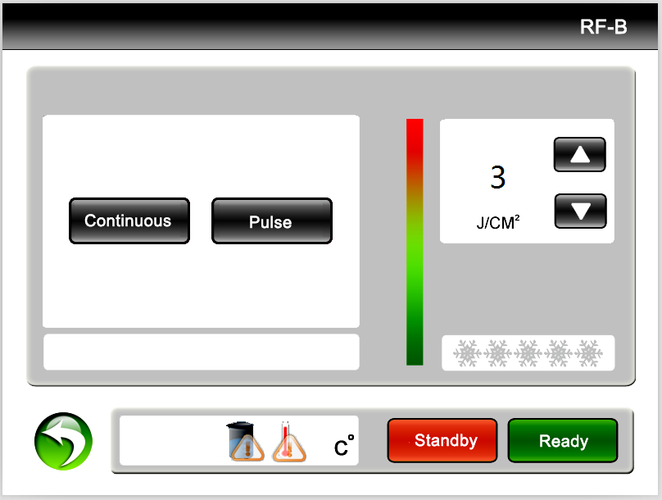
Click , the energy output is continuously if you keep pushing the switch on the handpiece. Click , the energy output is in pulse type.

